SATISFICING GAME APPROACH TO COLLABORATIVE DECISION
MAKING INCLUDING AIRPORT MANAGEMENT

ABSTRACT

Collaborative higher cognitive process has been used as a necessary paradigm to extend the potency of traffic flow management , together with takeoff or landing operations at airports. traffic management services and airlines are involved within the current CDM, however airfield management service, an important neutral, has not been concerned however, generally. This paper proposes a brand new CDM model that is called satisficing CDM, that's supported the satisficing theory of games. This model includes 3 main entities (ATC, airlines, and airfield management) in ATFM. the whole set of functions (preference, rejectability, and selectability) is established for every of the entities. Because the delay owing to ground or air holding doubtless alters the takeoff or the landing order of a flight, the sequence of takeoff and landing is set through the satisficing negotiation method. To demonstrate the utility of the developed intelligent system, experiments area unit run with real traffic within the terminal space of Sao Paulo. The experimental results show the importance and effectiveness of together with airfield management services in CDM. The sequences of takeoff and landing determined by the projected model largely meet the preferences of the 3 stakeholders within the given real traffic situations.

TABLE OF CONTENTS
CHAPTER NO. | TITLE | PAGE NO.
 | ABSTRACT  LIST OF FIGURES  LIST OF ABBREVIATIONS | i  iii  iv
1. | CHAPTER 1 : INTRODUCTION  - GENERAL  - OBJECTIVE  - EXISTING SYSTEM  1.3.1EXISTINGSYSTEM DISADVANTAGES  1.3.2 LITERATURE SURVEY  1.4 PROPOSED SYSTEM  1.4.1 PROPOSED SYSTEM ADVANTAGES
2. | CHAPTER 2 :PROJECT DESCRIPTION  2.1 GENERAL  2.2 METHODOLOGIES  2.2.1 MODULES NAME  2.2.2 MODULES EXPLANATION  2.2.3 MODULE DIAGRAM  2.2.4GIVEN INPUTAND EXPECTED OUTPUT  2.3 TECHNIQUE OR ALGORITHM
3. | CHAPTER 3 : REQUIREMENTS  3.1 General  3.2 Hardware REQUIREMENTS  3.3 Software REQUIREMENTS
4. | CHAPTER 4 : SYSTEM DESIGN  4.1 SYSTEM ARCHETECTURE
5. | CHAPTER 5 :SOFTWARE SPECIFICATION  5.1 general  5.2 features of java and bigdata  5.2.1 the java and hadoop framework  5.2.2 objective of java and hadoop  5.2.3 componets of hadoop frmework  5.2.4 HDFS ARchitecture  5.2.5 MAPReduce flowchart  5.3 Working with sqoop tool  5.4 working with hive tool  5.5 working with pig tool
6. | CHAPTER 6 : IMPLEMENTATION  6.1 GENERAL  6.2 IMPLEMENTATION
7. | CHAPTER 7 : SNAPSHOTS  7.1 GENERAL  7.2 VARIOUS SNAPSHOTS
8. | CHAPTER 8:APPLICATIONS AND FUTURE ENHANCEMENT  8.1 GENERAL  8.2 APPLICATIONS  8.3 FUTURE ENHANCEMENTS  8.4 CONCLUSION  8.5 REFERENCES

LIST OF FIGURES
FIGURE NO | NAME OF THE FIGURE | PAGE NO.
2.2.2 | Module Diagram
4.1 | Architecture Diagram
5.2.4 | Hdfs Archtecture
5.2.5 | MapReduce flowchart

LIST OF ABBREVATION

S.NO | ABBREVATION | EXPANSION
1. | HDFS | HadoopDistibutedFileSystem
2. | JVM | Java Virtual Machine
3. | JRE | Java Runtime Environment

CHAPTER 1
INTRODUCTION
  - GENERAL:
90% of the world’s data was generated in the last few years. Due to the advent of new technologies, devices, and communication means like social networking sites, the amount of data produced by mankind is growing rapidly every year. The amount of data produced by us from the beginning of time till 2003 was 5 billion gigabytes. If you pile up the data in the form of disks it may fill an entire football field. The same amount was created in every two days in 2011, and in every ten minutes in 2013. This rate is still growing enormously. Though all this information produced is meaningful and can be useful when processed, it is being neglected. Big Data is a collection of large datasets that cannot be processed using traditional computing techniques. It is not a single technique or a tool rather it involves many areas of business and technology.
1.2 OBJECTIVE:
In this paper we are analyzing Airport data by using hadoop tool along with some hadoop ecosystems like hdfs, mapreduce, sqoop, hive and pig. By using these tools we can process no limitation of data, no data lost problem, we can get high throughput, maintence cost also very less and it is a opensoure software,it is compatible on all the platforms since it is Java based.
1.3 EXISTING SYSTEM:
Existing concept deals with providing backend by using mysql which contains lot of drawbacks i.e data limitation is that processing time is high when the data is huge and once data is lost we cannot recover so thus we proposing concept by using Hadoop framework.
1.3.1DRAWBACKS IN EXISTING SYSTEM:
- We can process limitation of data.
- We get results with take more time and maintence cost is very high.

1.3.2 LITERATURE SURVEY:
Title : Optimization and Mediated Bartering Models for Ground Delay Programs
Author : Thomas Vossen1 and Michael Ball2
Year : 2005

Description: The Federal Aviation Administration (FAA) and the airline community within the United States have adopted a new paradigm for air traffic flow management, called Collaborative Decision Making (CDM). A principal goal of CDM is shared decision-making responsibility between the FAA and airlines, so as to increase airline control over decisions that involve economic tradeoffs. So far,CDMhas primarily led to enhancements in the implementation of Ground Delay Programs, by changing procedures for allocating slots to airlines and exchanging slots between airlines. In this paper,we discuss howthese procedures may be formalized through appropriately defined optimization models. In addition, we describe how inter-airline slot exchanges may be viewed as a bartering process, in which each “round” of bartering requires the solution of an optimization problem. We compare the resulting optimization problem with the current procedure for exchanging slots and discuss possibilities for increased decision-making capabilities by the airlines.

Title : Auctions for the Safe, Efficient and Equitable Allocation of Airspace
System Resources
Author : Michael Ball
Year : 2003

Description: In this paper, we present evidence of the need for the specification of property rights
associated with airport departure and arrival time slots and then provide the rationale and
means for using auctions to allocate such property rights. We provide a historical look at
slot allocation in the U.S. and the consequences of prior and current practices on both
safety and competition. It is shown that the particular characteristics of aviation slot
allocation suggest the need for three types of market mechanisms: an auction of longterm
leases of arrival and/or departure slots, a market that supports inter-airline exchange
of long-term leases and a near-real-time market that allows for the exchange of slots on a
particular day of operation. We describe how certain concepts and tools underlying
Collaborative Decision Making (CDM) provide a natural basis for developing the nearreal-
time market and present a broad overview of the special characteristics of aviationslot auctions and appropriate research topics.

Title : Measuring Ground Delay Program Effectiveness Using the Rate Control Index
Author : Robert L. Hoffman, Michael O. Ball
Year : 2000
Description: The increase in air traffic in the United States over the last 20 years has necessitated more frequent use of traffic flow management initiatives. In 1998, there were 187 ground delay programs (GDPs) run at San Francisco airport alone. As a result, there has been considerable interest both in the aviation and research communities regarding traffic flow management and its analysis. Since the primary purpose of a GDP is to control the rate of flow of aircraft into an airport, the typical metric for evaluating the performance of a GDP is the comparison of actual landings per hour with the planned landings per hour. Often times, upon execution of a ground delay program, the airport acceptance rate (AAR) is unexpectedly low due to weather or other conditions at the airport and not all of the aircraft delivered in a given hour can be accepted. In this case, the standard metric shows poor performance when, in reality, the program was executed as planned.

Title : Auctions for the Safe, Efficient and Equitable Allocation of Airspace
System Resources
Author : Michael Ball
Year : 2003

Description: In this paper, we present evidence of the need for the specification of property rights
associated with airport departure and arrival time slots and then provide the rationale and
means for using auctions to allocate such property rights. We provide a historical look at
slot allocation in the U.S. and the consequences of prior and current practices on both
safety and competition. It is shown that the particular characteristics of aviation slot
allocation suggest the need for three types of market mechanisms: an auction of longterm
leases of arrival and/or departure slots, a market that supports inter-airline exchange
of long-term leases and a near-real-time market that allows for the exchange of slots on a
particular day of operation. We describe how certain concepts and tools underlying
Collaborative Decision Making (CDM) provide a natural basis for developing the nearreal-
time market and present a broad overview of the special characteristics of aviationslot auctions and appropriate research topics.

1.4. PROPOSED SYSTEM:
Propsed concept deals with providing database by using hadoop tool we can analyze no limitation of data and simple add number of machines to the cluster andwe get results with less time, high throughput and maintence cost is very less and we are using joins,partations and bucketing techniques in hadoop.
1.4.1 ADVANTAGES IN PROPOSED SYSTEM:
- No data loss problem
- Efficient data processing.

CHAPTER 2
Methodologies of predicting Airport
2.1. GENERAL
In this paper we are analyzing Airport data by using hadoop framework along with some hadoop ecosystems like hdfs, mapreduce, sqoop, hive and pig. By using these tools we can process no limitation of data, no data lost problem, we can get high throughput, maintence cost also very less and it is a opensouresoftware,it is compatible on all the platforms since it is Java based

2.2 METHODOLOGIES
Following modules involves

2.2.1 MODULES
- Data Preprocessing Module
- Data Migration Module With Sqoop
- Data Analytic Module With Hive
- Data Analytic Module With Pig
- Data Analytic Module With MapReduce

Data Preprocessing Module
In this module we have to create Data set for Airport dataset it contain set of table such that Flight detail,user detail,payment mode,ticketinfo for certain period. this data set will be first provide into MySQL database with help of this dataset we analysis this project.

Data Migration Module with Sqoop
Now we are ready with dataset. So now our aim is transfer the dataset into hadoop(HDFS), that will be happen in this module.
Sqoop is a command-line interface application for transferring data between relational databases and Hadoop
In this module we fetch the dataset into hadoop (HDFS) using sqoop Tool. Using sqoop we have to perform lot of the function, such that if we want to fetch the particular column or if we want to fetch the dataset with specific condition that will be support by Sqoop Tool and data will be stored in hadoop (HDFS).
Data Analytic Module with Hive
Hive is a data ware house system for Hadoop. It runs SQL like queries called HQL (Hive query language) which gets internally converted to map reduce jobs. Hive was developed by Facebook. Hive supports Data definition Language (DDL), Data Manipulation Language (DML) and user defined functions.
In this module we have to analysis the dataset using HIVE tool which will be stored in hadoop (HDFS).For analysis dataset HIVE using HQL Language. Using hive we perform Tables creations, joins, Partition, Bucketing concept. Hive analysis the only Structure Language.
Data Analytic Module with Pig
Apache Pig is a high level data flow platform for execution Map Reduce programs of Hadoop. The language for Pig is pig Latin. Pig handles both structure and unstructured language. It is also top of the map reduce process running background.
In this module also used for analyzing the Data set through Pig using Latin Script data flow language.in this also we are doing all operators, functions and joins applying on the data see the result.

Data Analytic Module with MapReduce
MapReduce is a processing technique and a program model for distributed computing based on java. The MapReduce algorithm contains two important tasks, namely Map and Reduce.
In this module also used for analyzing the data set using MAP REDUCE. Map Reduce Run by Java Program.

2.2.2 MODULE DIAGRAMS:
Data Preprocessing Module Diagram
Flight detail
Flights
User detail
Airport Database[MYSQL]
Payment mode
Ticketinfo
Data Migration with Sqoop Module Diagram

Airport DATABASE[MYSQL]

HADOOP
HDFS
SQOOP
IMPORT & EXPORT

Data Analytic Module with Hive Module Diagram

Airport DATABASE [MYSQL]

HADOOP
HDFS
SQOOP
IMPORT & EXPORT
HIVE
[Query approach]
RESULT

Data Analytic with PIG Module Diagram

Airport DATABASE [MYSQL]

HADOOP
HDFS
SQOOP
IMPORT & EXPORT
PIG
[SCRIPTING Langue]
RESULT

Data Analytic Module with MapReduce
Airport DATABASE [MYSQL]

HADOOP
HDFS
SQOOP
IMPORT & EXPORT
MRJOBS
[Java programs]
RESULT

2.3. SYSTEM TECHNIQUES:
MapReduce is a processing technique and a program model for distributed computing based on java. The MapReduce algorithm contains two important tasks, namely Map and Reduce. Map takes a set of data and converts it into another set of data, where individual elements are broken down into tuples (key/value pairs). Secondly, reduce task, which takes the output from a map as an input and combines those data tuples into a smaller set of tuples. As the sequence of the name MapReduce implies, the reduce task is always performed after the map job.
The major advantage of MapReduce is that it is easy to scale data processing over multiple computing nodes. Under the MapReduce model, the data processing primitives are called mappers and reducers. Decomposing a data processing application into mappers and reducers is sometimes nontrivial. But, once we write an application in the MapReduce form, scaling the application to run over hundreds, thousands, or even tens of thousands of machines in a cluster is merely a configuration change. This simple scalability is what has attracted many programmers to use the MapReduce model.

The Algorithm
- Generally MapReduce paradigm is based on sending the computer to where the data resides!
- MapReduce program executes in three stages, namely map stage, shuffle stage, and reduce stage.
  - Map stage : The map or mapper’s job is to process the input data. Generally the input data is in the form of file or directory and is stored in the Hadoop file system (HDFS). The input file is passed to the mapper function line by line. The mapper processes the data and creates several small chunks of data.
  - Reduce stage : This stage is the combination of the Shuffle stage and the Reduce stage. The Reducer’s job is to process the data that comes from the mapper. After processing, it produces a new set of output, which will be stored in the HDFS.
CHAPTER 3
REQUIREMENTS ENGINEERING

3.1 GENERAL
These are the requirements for doing the project. Without using these tools and software’s we can’t do the project. So we have two requirements to do the project.
They are

1. Hardware Requirements.
2. Software Requirements.

3.2 HARDWARE REQUIREMENTS
The hardware requirements may serve as the basis for a contract for the implementation of the system and should therefore be a complete and consistent specification of the whole system. They are used by software engineers as the starting point for the system design. It shows what the system does and not how it should be implemented.

PROCESSOR : PENTIUM IV 2.6 GHz, Intel Core 2 Duo.
RAM : 4GB DD RAM
MONITOR : 15” COLOR
HARD DISK : 40 GB

  - SOFTWARE REQUIREMENTS
The software requirements document is the specification of the system. It should include both a definition and a specification of requirements. It is a set of what the system should do rather than how it should do it. The software requirements provide a basis for creating the software requirements specification. It is useful in estimating cost, planning team activities, performing tasks and tracking the team’s and tracking the team’s progress throughout the development activity.

Framework : Hadoop
Database : MY SQL 5.5
Lanuage : Pig, Hive, CoreJava
DataAccessTool : Sqoop
Operating System : cent os
IDE : Eclipse

CHAPTER 4
DESIGN ENGINEERING

4.1. SYSTEM ARCHITECTURE:
Airport DATABASE [MYSQL]

HADOOP
HDFS
SQOOP
IMPORT & EXPORT
HIVE
[Query approach]
RESULT
MRJOBS
[Java programs]
PIG
[SCRIPTING Langue]
EXPLANATION:
The proposed method performs well in the general population as well as in sub-populations. Results indicate that the proposed model significantly improves predictions over established baseline methods analyzing Airline performance. The goal of this study was to analyze How many times individual person traveled to different place and flight status.

CHAPTER 5
DEVELOPMENT TOOLS
5.1 GENERAL
This chapter is about the software language and the tools used in the development of the project. The platform used here is JAVA and Big Data.
5.2 FEATURES OF JAVA & BIGDATA
5.2.1 THE JAVA & HADOOP FRAMEWORK
Java is a programming language originally developed by James Gosling at Microsystems and released in 1995 as a core component of Sun Microsystems' Java platform. The language derives much of its syntax from C and C++ but has a simpler object model and fewer low-level facilities. Java applications are typically compiled to byte code that can run on any Java Virtual Machine (JVM) regardless of computer architecture. Java is general-purpose, concurrent, class-based, and object-oriented, and is specifically designed to have as few implementation dependencies as possible. It is intended to let application developers "write once, run anywhere".
Java is considered by many as one of the most influential programming languages of the 20th century, and is widely used from application software to web applications The java framework is a new platform independent that simplifies application development internet. Java technology's versatility, efficiency, platform portability, and security make it the ideal technology for network computing. From laptops to datacenters, game consoles to scientific supercomputers, cell phones to the Internet, Java is everywhere!
Big Data is a collection of large datasets that cannot be processed using traditional computing techniques. It is not a single technique or a tool, rather it involves many areas of business and technology. Big data involves the data produced by different devices and applications. Given below are some of the fields that come under the umbrella of Big Data.
Black Box Data: It is a component of helicopter, airplanes, and jets, etc. It captures voices of the flight crew, recordings of microphones and earphones, and the performance information of the aircraft.
Social Media Data: Social media such as Facebook and Twitter hold information and the views posted by millions of people across the globe.
Stock Exchange Data: The stock exchange data holds information about the ‘buy’ and ‘sell’ decisions made on a share of different companies made by the customers.
Power Grid Data: The power grid data holds information consumed by a particular node with respect to a base station.
Transport Data: Transport data includes model, capacity, distance and availability of a vehicle.
Search Engine Data: Search engines retrieve lots of data from different databases.
Thus Big Data includes huge volume, high velocity, and extensible variety of data. The data in it will be of three types.
- Structured data: Relational data.
- Semi Structured data: XML data.
- Unstructured data: Word, PDF, Text, Media Logs.
5.2.2 OBJECTIVES OF JAVA & BIGDATA
To see places of Java in Action in our daily life, explore java.com.

Why Software Developers Choose Java
Java has been tested, refined, extended, and proven by a dedicated community. And numbering more than 6.5 million developers, it's the largest and most active on the planet. With its versatility, efficiency, and portability, Java has become invaluable to developers by enabling them to:
- Write software on one platform and run it on virtually any other platform
- Create programs to run within a Web browser and Web services
- Develop server-side applications for online forums, stores, polls, HTML forms processing, and more
- Combine applications or services using the Java language to create highly customized applications or services
- Write powerful and efficient applications for mobile phones, remote processors, low-cost consumer products, and practically any other device with a digital heartbeat

Some Ways Software Developers Learn Java
- Today, many colleges and universities offer courses in programming for the Java platform. In addition, developers can also enhance their Java programming skills by reading Sun's java.sun.com Web site, subscribing to Java technology-focused newsletters, using the Java Tutorial and the New to Java Programming Center, and signing up for Web, virtual, or instructor-led courses.
ObjectOriented
To be an Object Oriented language, any language must follow at least the four characteristics.
1.Inheritance :It is the process of creating the new classes and using the behavior of the existing classes by extending them just to reuse the existing code and adding addition a features as needed.
2.Encapsulation: It is the mechanism of combining the information and providing the abstraction.
3.Polymorphism: As the name suggest one name multiple form, Polymorphism is the way of providing the different functionality by thefunctions having the same name based on the signatures of the methods.
4.Dynamic binding : Sometimes we don't have the knowledge of objects about their specific types while writing our code. It is the way of providing the maximum functionality to a program about the specific type at runtime.

Why Software Developers Choose Hadoop
Big Data is everywhere and there is almost an urgent need to collect and preserve whatever data is being generated, for the fear of missing out on something important. There is a huge amount of data floating around. What we do with it is all that matters right now. This is why Big Data Analytics is in the frontiers of IT. Big Data Analytics has become crucial as it aids in improving business, decision makings and providing the biggest edge over the competitors. This applies for organizations as well as professionals in the Analytics domain. For professionals, who are skilled in Big Data Analytics, there is an ocean of opportunities out there.
Big Data Challenges:
The major challenges associated with big data are as follows:
- Capturing data
- Storage
- Searching
- Sharing
- Transfer
- Analysis
- Presentation
To fulfill the above challenges, organizations normally take the help of enterprise servers.
Big Data Solutions
Traditional Enterprise Approach
In this approach, an enterprise will have a computer to store and process big data. For storage purpose, the programmers will take the help of their choice of database vendors such as Oracle, IBM, etc. In this approach, the user interacts with the application, which in turn handles the part of data storage and analysis.
Limitation
This approach works fine with those applications that process less voluminous data that can be accommodated by standard database servers, or up to the limit of the processor that is processing the data. But when it comes to dealing with huge amounts of scalable data, it is a hectic task to process such data through a single database bottleneck.

Google’s Solution:
Google solved this problem using an algorithm called MapReduce. This algorithm divides the task into small parts and assigns them to many computers, and collects the results from them which when integrated, form the result dataset.

Object of Hadoop
Using the solution provided by Google, Doug Cutting and his team developed an Open Source Project called HADOOP. Hadoop runs applications using the MapReduce algorithm, where the data is processed in parallel with others. In short, Hadoop is used to develop applications that could perform complete statistical analysis on huge amounts of data.
What is Hadoop?
Hadoop is an Apache open source framework written in java that allows distributed processing of large datasets across clusters of computers using simple programming models. The Hadoop framework application works in an environment that provides distributed storage and computation across clusters of computers. Hadoop is designed to scale up from single server to thousands of machines, each offering local computation and storage.

Hadoop Architecture
At its core, Hadoop has two major layers namely:
- Processing/Computation layer (MapReduce), and
- Storage layer (Hadoop Distributed File System).
HDFS:
Hadoop File System was developed using distributed file system design. It is run on commodity hardware. Unlike other distributed systems, HDFS is highly fault tolerant and designed using low-cost hardware. HDFS holds very large amount of data and provides easier access. To store such huge data, the files are stored across multiple machines. These files are stored in redundant fashion to rescue the system from possible data losses in case of failure. HDFS also makes applications available to parallel processing.

Features of HDFS
- It is suitable for the distributed storage and processing.
- Hadoop provides a command interface to interact with HDFS.
- The built-in servers of namenode and datanode help users to easily check the status of cluster.
- Streaming access to file system data.
- HDFS provides file permissions and authentication.

5.2.4 HDFS Architecture
Given below is the architecture of a Hadoop File System. HDFS follows the master-slave architecture and it has the following elements.
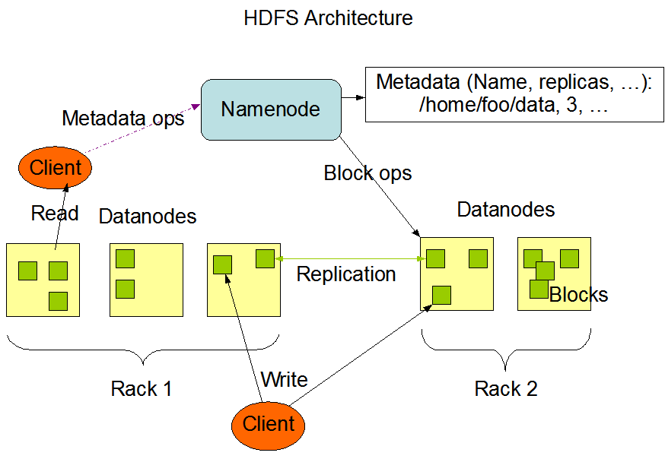
Namenode
The namenode is the commodity hardware that contains the GNU/Linux operating system and the namenode software. It is software that can be run on commodity hardware. The system having the namenode acts as the master server and it does the following tasks:
- Manages the file system namespace.
- Regulates client’s access to files.
- It also executes file system operations such as renaming, closing, and opening files and directories.

Datanode
The datanode is a commodity hardware having the GNU/Linux operating system and datanode software. For every node (Commodity hardware/System) in a cluster, there will be a datanode. These nodes manage the data storage of their system.
- Datanodes perform read-write operations on the file systems, as per client request.
- They also perform operations such as block creation, deletion, and replication according to the instructions of the namenode.
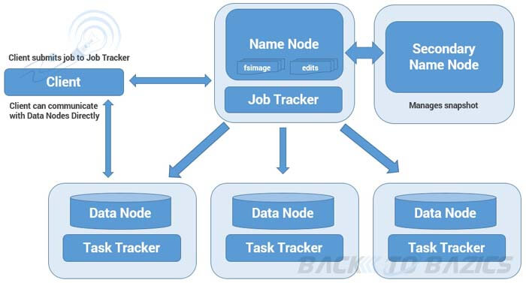

Block
Generally the user data is stored in the files of HDFS. The file in a file system will be divided into one or more segments and/or stored in individual data nodes. These file segments are called as blocks. In other words, the minimum amount of data that HDFS can read or write is called a Block. The default block size is 64MB, but it can be increased as per the need to change in HDFS configuration.
Jobtracker
It is a master service and it allocates tasks to the task trackers and also monitoring the job scheduling.
Tasktracker
A TaskTracker is a node in the cluster that accepts tasks - Map, Reduce and Shuffle operations - from a JobTracker
Secondarynamenode
It is a separate physical machine which acts as a helper of name node. It performs periodic check points. It communicates with the name node and take snapshot of meta data which helps minimize downtime and loss of data. It is a master service and backup for metadata not for Namenode.

Goals of HDFS
- Fault detection and recovery: Since HDFS includes a large number of commodity hardware, failure of components is frequent. Therefore HDFS should have mechanisms for quick and automatic fault detection and recovery.
- Huge datasets: HDFS should have hundreds of nodes per cluster to manage the applications having huge datasets.
- Hardware at data: A requested task can be done efficiently, when the computation takes place near the data. Especially where huge datasets are involved, it reduces the network traffic and increases the throughput.

Mapreduce:
MapReduce is a framework using which we can write applications to process huge amounts of data, in parallel, on large clusters of commodity hardware in a reliable manner.

What is MapReduce?
MapReduce is a processing technique and a program model for distributed computing based on java. The MapReduce algorithm contains two important tasks, namely Map and Reduce. Map takes a set of data and converts it into another set of data, where individual elements are broken down into tuples (key/value pairs). Secondly, reduce task, which takes the output from a map as an input and combines those data tuples into a smaller set of tuples. As the sequence of the name MapReduce implies, the reduce task is always performed after the map job.
The major advantage of MapReduce is that it is easy to scale data processing over multiple computing nodes. Under the MapReduce model, the data processing primitives are called mappers and reducers. Decomposing a data processing application into mappers and reducers is sometimes nontrivial. But, once we write an application in the MapReduce form, scaling the application to run over hundreds, thousands, or even tens of thousands of machines in a cluster is merely a configuration change. This simple scalability is what has attracted maprogrammers to use the MapReduce model.
5.2.5 MapReduce FlowCart Ex: WordCount
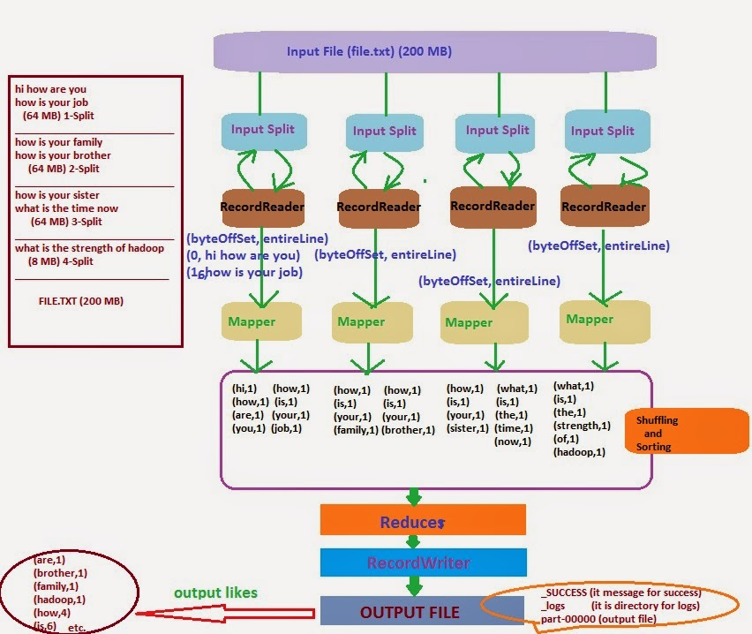
5.3 WORKING WITH SQOOP
Sqoop:
The traditional application management system, that is, the interaction of applications with relational database using RDBMS, is one of the sources that generate Big Data. Such Big Data, generated by RDBMS, is stored in Relational Database Servers in the relational database structure.
When Big Data storages and analyzers such as MapReduce, Hive, HBase, Cassandra, Pig, etc. of the Hadoop ecosystem came into picture, they required a tool to interact with the relational database servers for importing and exporting the Big Data residing in them. Here, Sqoop occupies a place in the Hadoop ecosystem to provide feasible interaction between relational database server and Hadoop’s HDFS.
Sqoop: “SQL to Hadoop and Hadoop to SQL”

Sqoop is a tool designed to transfer data between Hadoop and relational database servers. It is used to import data from relational databases such as MySQL, Oracle to Hadoop HDFS, and export from Hadoop file system to relational databases. It is provided by the Apache Software Foundation.

How Sqoop Works?
The following image describes the workflow of Sqoop.
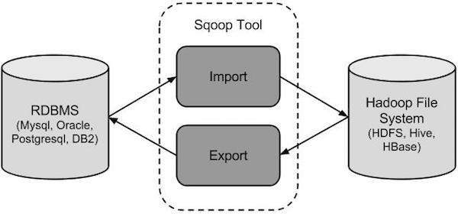

Sqoop Import
The import tool imports individual tables from RDBMS to HDFS. Each row in a table is treated as a record in HDFS. All records are stored as text data in text files or as binary data in Avro and Sequence files.

Sqoop Export
The export tool exports a set of files from HDFS back to an RDBMS. The files given as input to Sqoop contain records, which are called as rows in table. Those are read and parsed into a set of records and delimited with user-specified delimiter.
5.4 WORKING WITH HIVE:
Hive:
Introduction:
The term ‘Big Data’ is used for collections of large datasets that include huge volume, high velocity, and a variety of data that is increasing day by day. Using traditional data management systems, it is difficult to process Big Data. Therefore, the Apache Software Foundation introduced a framework called Hadoop to solve Big Data management and processing challenges.
The Hadoop ecosystem contains different sub-projects (tools) such as Sqoop, Pig, and Hive that are used to help Hadoop modules.
- Sqoop: It is used to import and export data to and fro between HDFS and RDBMS.
- Hive: It is a platform used to develop SQL type scripts to do Map Reduce operations.

Note: There are various ways to execute Map Reduce operations:
- The traditional approach using Java Map Reduce program for structured, semi-structured, and unstructured data.
- The scripting approach for Map Reduce to process structured and semi structured data using Pig.
- The Hive Query Language (HiveQL or HQL) for Map Reduce to process structured data using Hive.

What is Hive?
Hive is a data warehouse infrastructure tool to process structured data in Hadoop. It resides on top of Hadoop to summarize Big Data, and makes querying and analyzing easy.
Initially Hive was developed by Face book,later the Apache Software Foundation took it up and developed it further as an open source under the name Apache Hive. It is used by different companies. For example, Amazon uses it in Amazon Elastic Map Reduce.

Features of Hive
- It stores schema in a database and processed data into HDFS.
- It is designed for OLAP.
- It provides SQL type language for querying called HiveQL or HQL.
- It is familiar, fast, scalable, and extensible.

Architecture of Hive
The following component diagram depicts the architecture of Hive:
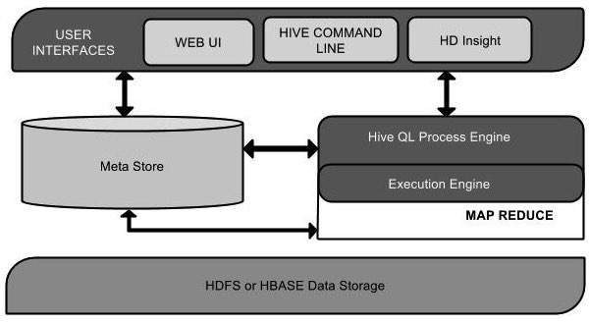

This component diagram contains different units. The following table describes each unit:
Unit Name | Operation
User Interface | Hive is data warehouse infrastructure software that can create interaction between user and HDFS. The user interfaces that Hive supports are Hive Web UI, Hive command line, and Hive HD Insight (In Windows server).
Meta Store | Hive chooses respective database servers to store the schema or Metadata of tables, databases, columns in a table, their data types, and HDFS mapping.
HiveQL Process Engine | HiveQL is similar to SQL for querying on schema info on the Megastore. It is one of the replacements of traditional approach for Map Reduce program. Instead of writing Map Reduce program in Java, we can write a query for Map Reduce job and process it.
Execution Engine | The conjunction part of HiveQL process Engine and Map Reduce is Hive Execution Engine. Execution engine processes the query and generates results as same as Map Reduce results. It uses the flavor of Map Reduce.
HDFS or HBASE | Hadoop distributed file system or HBASE are the data storage techniques to store data into file system.

Working of Hive
The following diagram depicts the workflow between Hive and Hadoop
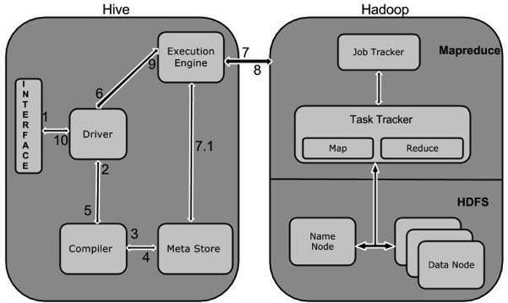
The following table defines how Hive interacts with Hadoop framework:
Step No. | Operation
1 | Execute Query  The Hive interface such as Command Line or Web UI sends query to Driver (any database driver such as JDBC, ODBC, etc.) to execute.
2 | Get Plan  The driver takes the help of query compiler that parses the query to check the syntax and query plan or the requirement of query.
3 | Get Metadata  The compiler sends metadata request to Metastore (any database).
4 | Send Metadata  Metastore sends metadata as a response to the compiler.
5 | Send Plan  The compiler checks the requirement and resends the plan to the driver. Up to here, the parsing and compiling of a query is complete.
6 | Execute Plan  The driver sends the execute plan to the execution engine.
7 | Execute Job  Internally, the process of execution job is a MapReduce job. The execution engine sends the job to JobTracker, which is in Name node and it assigns this job to TaskTracker, which is in Data node. Here, the query executes MapReduce job.
7.1 | Metadata Ops  Meanwhile in execution, the execution engine can execute metadata operations with Metastore.
8 | Fetch Result  The execution engine receives the results from Data nodes.
9 | Send Results  The execution engine sends those resultant values to the driver.
10 | Send Results  The driver sends the results to Hive Interfaces.

5.5 WORKING WITH PIG:
What is pig?
Apache Pig is a high level data flow platform for execution Map Reduce programs of Hadoop. The language for Pig is pig Latin.
The Pig scripts get internally converted to Map Reduce jobs and get executed on data stored in HDFS. Every task which can be achieved using PIG can also be achieved using java used in Map reduce.
Why do we need apache pig
Programmers who are not so good at Java normally used to struggle working with Hadoop, especially while performing any MapReduce tasks. Apache Pig is a boon for all such programmers.
- Using Pig Latin, programmers can perform MapReduce tasks easily without having to type complex codes in Java.
- Apache Pig uses multi-query approach, thereby reducing the length of codes. For example, an operation that would require you to type 200 lines of code (LoC) in Java can be easily done by typing as less as just 10 LoC in Apache Pig. Ultimately Apache Pig reduces the development time by almost 16 times.
- Pig Latin is SQL-like language and it is easy to learn Apache Pig when you are familiar with SQL.
- Apache Pig provides many built-in operators to support data operations like joins, filters, ordering, etc. In addition, it also provides nested data types like tuples, bags, and maps that are missing from MapReduce.

Features of pig
Apache Pig comes with the following features −
- Rich set of operators − It provides many operators to perform operations like join, sort, filer, etc.
- Ease of programming − Pig Latin is similar to SQL and it is easy to write a Pig script if you are good at SQL.
- Optimization opportunities − The tasks in Apache Pig optimize their execution automatically, so the programmers need to focus only on semantics of the language.
- Extensibility − Using the existing operators, users can develop their own functions to read, process, and write data.
- UDF’s − Pig provides the facility to create User-defined Functions in other programming languages such as Java and invoke or embed them in Pig Scripts.
- Handles all kinds of data − Apache Pig analyzes all kinds of data, both structured as well as unstructured. It stores the results in HDFS.

Difference between pig & hive
Apache Pig | Hive
Apache Pig uses a language called Pig Latin. It was originally created atYahoo. | Hive uses a language called HiveQL. It was originally created at Facebook.
Pig Latin is a data flow language. | HiveQL is a query processing language.
Pig Latin is a procedural language and it fits in pipeline paradigm. | HiveQL is a declarative language.
Apache Pig can handle structured, unstructured, and semi-structured data. | Hive is mostly for structured data.

History of pig
In 2006, Apache Pig was developed as a research project at Yahoo, especially to create and execute MapReduce jobs on every dataset. In 2007, Apache Pig was open sourced via Apache incubator. In 2008, the first release of Apache Pig came out. In 2010, Apache Pig graduated as an Apache top-level project.

Applications of Apache Pig
Apache Pig is generally used by data scientists for performing tasks involving ad-hoc processing and quick prototyping. Apache Pig is used −
- To process huge data sources such as web logs.
- To perform data processing for search platforms.
- To process time sensitive data loads.

Pig architecture
The language used to analyze data in Hadoop using Pig is known as Pig Latin. It is a highlevel data processing language which provides a rich set of data types and operators to perform various operations on the data.
To perform a particular task Programmers using Pig, programmers need to write a Pig script using the Pig Latin language, and execute them using any of the execution mechanisms Grunt Shell, UDFs, and Embedded. After execution, these scripts will go through a series of transformations applied by the Pig Framework, to produce the desired output.
Internally, Apache Pig converts these scripts into a series of MapReduce jobs, and thus, it makes the programmer’s job easy. The architecture of Apache Pig is shown below.
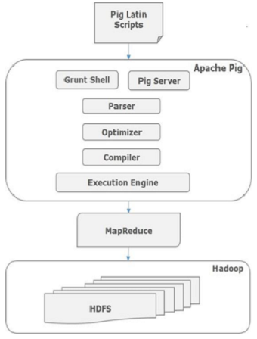

CHAPTER 6
IMPLEMENTATION
6.1 GENERAL
In this we implement the coding part using eclipse. Below are the coding’s that are used to generate the domain module for electronic text books. Here the proposed techniques are used in the coding part to generate the e-books.

6.2 Restore Backup File into Mysql Database:
Restore Backup File Into Mysql Database
training@localhost ~]$ mysql -u training -p
Enter password: training
Welcome to the MySQL monitor. Commands end with ; or \g.
Your MySQL connection id is 7
Server version: 5.0.77 Source distribution
Type 'help;' or '\h' for help. Type '\c' to clear the buffer.
mysql> show databases;
| information_schema |
| movielens |
| training
mysql> use movielens;
Reading table information for completion of table and column names
You can turn off this feature to get a quicker startup with -A
Database changed

mysql> show tables;
+---------------------+
| Tables_in_movielens |
+---------------------+
| flight |
| flight_detail |
| pay_mode |
| pess_detail |
| ticketinfo |

Data Migration Module with Sqoop
How To Import Table(flight)Mysql Database To Hadoop[HDFS]:Using Sqoop Tool
[training@localhost ~]$ sqoop import --connect jdbc:mysql://localhost/movielens --username training –password --table flight --m 1 --target-dir fligh
16/07/08 22:11:35 WARN tool.BaseSqoopTool: Setting your password on the command-line is insecure. Consider using -P instead.
16/07/08 22:11:35 INFO manager.MySQLManager: Preparing to use a MySQL streaming resultset.
16/07/08 22:11:35 INFO tool.CodeGenTool: Beginning code generation
16/07/08 22:11:36 INFO manager.SqlManager: Executing SQL statement: SELECT t.* FROM `wet` AS t LIMIT 1
16/07/08 22:11:36 INFO orm.CompilationManager: HADOOP_HOME is /usr/lib/hadoop
16/07/08 22:11:36 INFO orm.CompilationManager: Found hadoop core jar at: /usr/lib/hadoop/hadoop-core.jar
16/07/08 22:11:38 INFO orm.CompilationManager: Writing jar file: /tmp/sqoop-training/compile/6355366d2b4fa426a610994debfb6974/wet.jar
16/07/08 22:11:38 WARN manager.MySQLManager: It looks like you are importing from mysql.
16/07/08 22:11:38 WARN manager.MySQLManager: This transfer can be faster! Use the --direct
16/07/08 22:11:38 WARN manager.MySQLManager: option to exercise a MySQL-specific fast path.
16/07/08 22:11:38 INFO manager.MySQLManager: Setting zero DATETIME behavior to convertToNull (mysql)
16/07/08 22:11:38 INFO mapreduce.ImportJobBase: Beginning import of wet
16/07/08 22:11:40 INFO mapred.JobClient: Running job: job_201607082158_0001
16/07/08 22:11:41 INFO mapred.JobClient: map 0% reduce 0%
16/07/08 22:11:47 INFO mapred.JobClient: map 100% reduce 0%
16/07/08 22:11:47 INFO mapred.JobClient: Job complete: job_201607082158_0001
16/07/08 22:11:47 INFO mapred.JobClient: Counters: 12
How To Import Table(flightdetail)Mysql Database To Hadoop[HDFS]:Using Sqoop Tool
[training@localhost ~]$ sqoop import --connect jdbc:mysql://localhost/movielens --username training --password training --table flight_detail --m 1 --target-dir fdetail
16/07/30 12:55:08 WARN tool.BaseSqoopTool: Setting your password on the command-line is insecure. Consider using -P instead.
16/07/30 12:55:08 INFO manager.MySQLManager: Preparing to use a MySQL streaming resultset.
16/07/30 12:55:08 INFO tool.CodeGenTool: Beginning code generation
16/07/30 12:55:08 INFO manager.SqlManager: Executing SQL statement: SELECT t.* FROM `cust` AS t LIMIT 1
16/07/30 12:55:08 INFO orm.CompilationManager: HADOOP_HOME is /usr/lib/hadoop
16/07/30 12:55:08 INFO orm.CompilationManager: Found hadoop core jar at: /usr/lib/hadoop/hadoop-core.jar
16/07/30 12:55:09 ERROR orm.CompilationManager: Could not rename /tmp/sqoop-training/compile/de7c03aacaaa2f78d1ee5970b96a2086/cust.java to /home/training/./cust.java
java.io.IOException: Destination '/home/training/./cust.java' already exists
16/07/30 12:55:09 INFO orm.CompilationManager: Writing jar file: /tmp/sqoop-training/compile/de7c03aacaaa2f78d1ee5970b96a2086/cust.jar
16/07/30 12:55:09 WARN manager.MySQLManager: It looks like you are importing from mysql.
16/07/30 12:55:09 WARN manager.MySQLManager: This transfer can be faster! Use the --direct
16/07/30 12:55:09 WARN manager.MySQLManager: option to exercise a MySQL-specific fast path.
16/07/30 12:55:09 INFO manager.MySQLManager: Setting zero DATETIME behavior to convertToNull (mysql)
16/07/30 12:55:09 INFO mapreduce.ImportJobBase: Beginning import of cust
16/07/30 12:55:10 INFO mapred.JobClient: Running job: job_201607301043_0002
16/07/30 12:55:11 INFO mapred.JobClient: map 0% reduce 0%
16/07/30 12:55:16 INFO mapred.JobClient: map 100% reduce 0%
16/07/30 12:55:16 INFO mapred.JobClient: Job complete: job_201607301043_0002
16/07/30 12:55:16 INFO mapred.JobClient: Counters: 12
16/07/30 12:55:16 INFO mapred.JobClient: Job Counters
16/07/30 12:55:16 INFO mapred.JobClient: SLOTS_MILLIS_MAPS=4564
16/07/30 12:55:16 INFO mapred.JobClient: Total time spent by all reduces waiting after reserving slots (ms)=0
16/07/30 12:55:16 INFO mapred.JobClient: Total time spent by all maps waiting after reserving slots (ms)=0
16/07/30 12:55:16 INFO mapred.JobClient: Launched map tasks=1
16/07/30 12:55:16 INFO mapred.JobClient: SLOTS_MILLIS_REDUCES=0
16/07/30 12:55:16 INFO mapred.JobClient: FileSystemCounters
16/07/30 12:55:16 INFO mapred.JobClient: HDFS_BYTES_READ=87
16/07/30 12:55:16 INFO mapred.JobClient: FILE_BYTES_WRITTEN=66104
16/07/30 12:55:16 INFO mapred.JobClient: HDFS_BYTES_WRITTEN=80530
16/07/30 12:55:16 INFO mapred.JobClient: Map-Reduce Framework
16/07/30 12:55:16 INFO mapred.JobClient: Map input records=943
16/07/30 12:55:16 INFO mapred.JobClient: Spilled Records=0
16/07/30 12:55:16 INFO mapred.JobClient: Map output records=943
16/07/30 12:55:16 INFO mapred.JobClient: SPLIT_RAW_BYTES=87
16/07/30 12:55:16 INFO mapreduce.ImportJobBase: Transferred 78.6426 KB in 6.9338 seconds (11.3419 KB/sec)
16/07/30 12:55:16 INFO mapreduce.ImportJobBase: Retrieved 943 records.
How To See List-Databases in Mysql Database :Using Sqoop Tool
[training@localhost ~]$ sqoop list-databases --connect jdbc:mysql://localhost --username training --password training
16/07/08 22:29:25 WARN tool.BaseSqoopTool: Setting your password on the command-line is insecure. Consider using -P instead.
16/07/08 22:29:25 INFO manager.MySQLManager: Preparing to use a MySQL streaming resultset.
----------------------
information_schema
movielens --------- o/p
training
[training@localhost ~]$

How To See List-Tables in Mysql Database :Using Sqoop Tool
[training@localhost ~]$ sqoop list-tables --connect jdbc:mysql://localhost/movielens --username training --password training
16/07/08 22:32:04 WARN tool.BaseSqoopTool: Setting your password on the command-line is insecure. Consider using -P instead.
16/07/08 22:32:05 INFO manager.MySQLManager: Preparing to use a MySQL streaming resultset.

flight
flight_detail
pay_mode
pess_detail
ticketinfo

Working With Eval and Query[show dtabases]
[training@localhost ~]$ sqoop eval --connect jdbc:mysql://localhost --username training --password training --query "show databases"
16/07/08 22:37:21 WARN tool.BaseSqoopTool: Setting your password on the command-line is insecure. Consider using -P instead.
16/07/08 22:37:21 INFO manager.MySQLManager: Preparing to use a MySQL streaming resultset.
------------------------
| SCHEMA_NAME |
------------------------
| information_schema | -------> o/p
| movielens |
| training |

To Retrieve the Particular columns
[training@localhost ~]$ sqoop import --connect jdbc:mysql://localhost/movielens --username training --password training --table flight --fields-terminated-by '\t' --m 1 --columns "flightid,airline_name,from_location,to_location"
6/07/30 11:10:04 WARN tool.BaseSqoopTool: Setting your password on the command-line is insecure. Consider using -P instead.
16/07/30 11:10:04 INFO manager.MySQLManager: Preparing to use a MySQL streaming resultset.
16/07/30 11:10:04 INFO tool.CodeGenTool: Beginning code generation
16/07/30 11:10:04 INFO manager.SqlManager: Executing SQL statement: SELECT t.* FROM `flight` AS t LIMIT 1
16/07/30 11:10:04 INFO orm.CompilationManager: HADOOP_HOME is /usr/lib/hadoop
16/07/30 11:10:04 INFO orm.CompilationManager: Found hadoop core jar at: /usr/lib/hadoop/hadoop-core.jar
16/07/30 11:10:05 ERROR orm.CompilationManager: Could not rename /tmp/sqoop-training/compile/8fb8712f3ac4bc6dbc3d4c87c0555327/flight.java to /home/training/./flight.java
java.io.IOException: Destination '/home/training/./flight.java' already exists.
path.
16/07/30 13:03:11 INFO manager.MySQLManager: Setting zero DATETIME behavior to convertToNull (mysql)
16/07/30 13:03:12 INFO mapreduce.ImportJobBase: Beginning import of payment
16/07/30 13:03:12 INFO mapred.JobClient: Running job: job_201607301043_0003
16/07/30 13:03:13 INFO mapred.JobClient: map 0% reduce 0%
16/07/30 13:03:19 INFO mapred.JobClient: map 100% reduce 0%
16/07/30 13:03:19 INFO mapred.JobClient: Job complete: job_201607301043_0003
16/07/30 13:03:19 INFO mapred.JobClient: Counters: 12
16/07/30 13:03:19 INFO mapred.JobClient: Job Counters
16/07/30 13:03:19 INFO mapred.JobClient: SLOTS_MILLIS_MAPS=5634
16/07/30 13:03:19 INFO mapred.JobClient: Total time spent by all reduces waiting after reserving slots (ms)=0
16/07/30 13:03:19 INFO mapred.JobClient: Total time spent by all maps waiting after reserving slots (ms)=0
16/07/30 13:03:19 INFO mapred.JobClient: Launched map tasks=1
16/07/30 13:03:19 INFO mapred.JobClient: SLOTS_MILLIS_REDUCES=0
16/07/30 13:03:19 INFO mapred.JobClient: FileSystemCounters
16/07/30 13:03:19 INFO mapred.JobClient: HDFS_BYTES_READ=87
16/07/30 13:03:19 INFO mapred.JobClient: FILE_BYTES_WRITTEN=66112
16/07/30 13:03:19 INFO mapred.JobClient: HDFS_BYTES_WRITTEN=1165977
16/07/30 13:03:19 INFO mapred.JobClient: Map-Reduce Framework
16/07/30 13:03:19 INFO mapred.JobClient: Map input records=17478
16/07/30 13:03:19 INFO mapred.JobClient: Spilled Records=0
16/07/30 13:03:19 INFO mapred.JobClient: Map output records=17478
16/07/30 13:03:19 INFO mapred.JobClient: SPLIT_RAW_BYTES=87
16/07/30 13:03:20 INFO mapreduce.ImportJobBase: Transferred 1.112 MB in 7.7727 seconds (146.4936 KB/sec)
To Retrieve the Particular columns with conditions appaly
To Retrieve the Particular columns with condition
sqoop import --connect jdbc:mysql://localhost/movielens --username training --password training --table ticketinfo --m 1 --columns "ticketid,username,flightid,flight_dept_date" --where "delay='20min'" --target-dir tic11
16/07/30 15:12:45 WARN tool.BaseSqoopTool: Setting your password on the command-line is insecure. Consider using -P instead.
16/07/30 15:12:45 INFO manager.MySQLManager: Preparing to use a MySQL streaming resultset.
16/07/30 15:12:45 INFO tool.CodeGenTool: Beginning code generation
16/07/30 15:12:45 INFO manager.SqlManager: Executing SQL statement: SELECT t.* FROM `ticketinfo` AS t LIMIT 1
16/07/30 15:12:45 INFO orm.CompilationManager: HADOOP_HOME is /usr/lib/hadoop
16/07/30 15:12:45 INFO orm.CompilationManager: Found hadoop core jar at: /usr/lib/hadoop/hadoop-core.jar
16/07/30 15:12:46 ERROR orm.CompilationManager: Could not rename /tmp/sqoop-training/compile/62bda99ce58b44e3ab3b2a43b05fe7a5/ticketinfo.java to /home/training/./ticketinfo.java
t.* FROM `payment` AS t LIMIT 1
16/07/30 13:03:11 INFO orm.CompilationManager: HADOOP_HOME is /usr/lib/hadoop
16/07/30 13:03:11 INFO orm.CompilationManager: Found hadoop core jar at: /usr/lib/hadoop/hadoop-core.jar
16/07/30 13:03:11 INFO orm.CompilationManager: Writing jar file: /tmp/sqoop-training/compile/29c8f37a4b55f15599069c14ff851a72/payment.jar
16/07/30 13:03:11 WARN manager.MySQLManager: It looks like you are importing from mysql.
16/07/30 13:03:11 WARN manager.MySQLManager: This transfer can be faster! Use the --direct
16/07/30 13:03:11 WARN manager.MySQLManager: option to exercise a MySQL-specific fast path.
16/07/30 13:03:11 INFO manager.MySQLManager: Setting zero DATETIME behavior to convertToNull (mysql)
16/07/30 13:03:12 INFO mapreduce.ImportJobBase: Beginning import of payment
16/07/30 13:03:12 INFO mapred.JobClient: Running job: job_201607301043_0003
16/07/30 13:03:13 INFO mapred.JobClient: map 0% reduce 0%
16/07/30 13:03:19 INFO mapred.JobClient: map 100% reduce 0%
16/07/30 13:03:19 INFO mapred.JobClient: Job complete: job_201607301043_0003
16/07/30 13:03:19 INFO mapred.JobClient: Counters: 12
16/07/30 13:03:19 INFO mapred.JobClient: Job Counters
16/07/30 13:03:19 INFO mapred.JobClient: SLOTS_MILLIS_MAPS=5634
16/07/30 13:03:19 INFO mapred.JobClient: Total time spent by all reduces waiting after reserving slots (ms)=0
16/07/30 13:03:19 INFO mapred.JobClient: Total time spent by all maps waiting after reserving slots (ms)=0
16/07/30 13:03:19 INFO mapred.JobClient: Launched map tasks=1
16/07/30 13:03:19 INFO mapred.JobClient: SLOTS_MILLIS_REDUCES=0
16/07/30 13:03:19 INFO mapred.JobClient: FileSystemCounters
16/07/30 13:03:19 INFO mapred.JobClient: HDFS_BYTES_READ=87
16/07/30 13:03:19 INFO mapred.JobClient: FILE_BYTES_WRITTEN=66112
16/07/30 13:03:19 INFO mapred.JobClient: HDFS_BYTES_WRITTEN=1165977
16/07/30 13:03:19 INFO mapred.JobClient: Map-Reduce Framework
16/07/30 13:03:19 INFO mapred.JobClient: Map input records=17478
16/07/30 13:03:19 INFO mapred.JobClient: Spilled Records=0
16/07/30 13:03:19 INFO mapred.JobClient: Map output records=17478
16/07/30 13:03:19 INFO mapred.JobClient: SPLIT_RAW_BYTES=87
16/07/30 13:03:20 INFO mapreduce.ImportJobBase: Transferred 1.112 MB in 7.7727 seconds (146.4936 KB/sec)

How To Create Table In Hive By using Sqoop
[training@localhost ~]$ sqoop create-hive-table --connect jdbc:mysql://localhost/movielens --username training --password training --table flight
16/08/01 14:23:44 WARN tool.BaseSqoopTool: Setting your password on the command-line is insecure. Consider using -P instead.
16/08/01 14:23:44 INFO tool.BaseSqoopTool: Using Hive-specific delimiters for output. You can override
16/08/01 14:23:44 INFO tool.BaseSqoopTool: delimiters with --fields-terminated-by, etc.
16/08/01 14:23:44 INFO manager.MySQLManager: Preparing to use a MySQL streaming resultset.
16/08/01 14:23:44 INFO hive.HiveImport: Loading uploaded data into Hive
16/08/01 14:23:44 INFO manager.SqlManager: Executing SQL statement: SELECT t.* FROM `bill` AS t LIMIT 1
16/08/01 14:23:46 INFO hive.HiveImport: Hive history file=/tmp/training/hive_job_log_training_201608011423_1685744897.txt
16/08/01 14:23:51 INFO hive.HiveImport: OK
16/08/01 14:23:51 INFO hive.HiveImport: Time taken: 4.042 seconds
16/08/01 14:23:51 INFO hive.HiveImport: Hive import complete.
HOW TO ANALIZE THE AIRPORT DATA THROUGH HIVE
HOW TO OPEN HIVE
[training@localhost ~]$ hive
Hive history file=/tmp/training/hive_job_log_training_201607102157_2036945403.txt
hive>
hive> show databases;
OK
default
Time taken: 2.185 seconds

HOW TO CREATE DATABASE
hive> create database airport;
OK
Time taken: 0.251 seconds

hive> use airport;
OK
Time taken: 0.021 seconds

TABLES IN HIVE
1. INTERNAL TABLE CREATION(fight)
hive> create table flight1(airlineid string,flightid bigint,airlinename string,fromlocation string,tolocation string,deptime string,arrivaltime string,duration bigint,totalseats bigint,terminal string)
> row format delimited
> fields terminated by ',';
hive>

2. LOAD THE DATA INTO INTERNAL TABLE

hive> load data local inpath '/home/training/Flight.csv' into table fli;

How to see the total data

hive> select * from flight1 limit 3;
-----------------------------------------
OK
00A 6521 Air Arabia chennai Sharjah 5:00 18:00 7 200 Anna
00AK 6522 AirAsia chennai KualaLumpur 5:30 18:30 8 180 Anna
00AL 6523 AirAustral chennai Bangkok 6:00 19:00 6 200 Anna
Time taken: 0.113 seconds

How to apply conditions and see the result
hive> select airlineid,flightid,fromlocation,tolocation from flight1 where tolocation='Bangalore'
Total MapReduce jobs = 1
Launching Job 1 out of 1
Number of reduce tasks is set to 0 since there's no reduce operator
Starting Job = job_201608051230_0054, Tracking URL = http://localhost:50030/jobdetails.jsp?jobid=job_201608051230_0054
Kill Command = /usr/lib/hadoop/bin/hadoop job -Dmapred.job.tracker=localhost:8021 -kill job_201608051230_0054
2016-08-09 13:56:01,859 Stage-1 map = 0%, reduce = 0%
2016-08-09 13:56:02,868 Stage-1 map = 100%, reduce = 100%
Ended Job = job_201608051230_0054
OK
airlineid flightid fromlocation tolocation
00FL 6530 chennai Bangalore
00NG 6570 chennai Bangalore
00VL 6577 chennai Bangalore

hive> select tid,userid,uname,flightid,fromlocation,tolocation,delay from ticket1 where delay>'10';
otal MapReduce jobs = 1
Launching Job 1 out of 1
Number of reduce tasks is set to 0 since there's no reduce operator
Starting Job = job_201608051230_0083, Tracking URL = http://localhost:50030/jobdetails.jsp?jobid=job_201608051230_0083
Kill Command = /usr/lib/hadoop/bin/hadoop job -Dmapred.job.tracker=localhost:8021 -kill job_201608051230_0083
2016-08-09 17:18:55,652 Stage-1 map = 0%, reduce = 0%
2016-08-09 17:18:56,656 Stage-1 map = 100%, reduce = 0%
2016-08-09 17:18:57,665 Stage-1 map = 100%, reduce = 100%
Ended Job = job_201608051230_0083
===========================================================================
OK
68746 137 Arvind Krishna 6557 chennai Colombo 20
68768 159 Babu Antony 6579 chennai Hong Kong 20
68845 236 Duniya Vijay 6557 chennai Colombo 20
68867 258 Gireesh Sahedev 6579 chennai Hong Kong 20
68944 335 K.N. Singh 6557 chennai Colombo 20

HIVE JOINS
INNER JOIN:
hive> select tid,userid,uname,fromlocation,tolocation,status from ticket1 where status='arrived' limit 5;
Total MapReduce jobs = 1
Launching Job 1 out of 1
Number of reduce tasks is set to 0 since there's no reduce operator
Starting Job = job_201608051230_0099, Tracking URL = http://localhost:50030/jobdetails.jsp?jobid=job_201608051230_0099
Kill Command = /usr/lib/hadoop/bin/hadoop job -Dmapred.job.tracke

68711 102 Akshay Anand chennai Kuala umpur arrived
68713 104 Akshaye Khanna chennai Coimbatore arrived
68716 107 Allari Naresh chennai Bengaluru arrived
68717 108 Allu Arjun chennai Kuala Lumpur arrived
68720 111 Amar Talwar chennai Mauritius arrived
Time taken: 4.191 seconds
LEFT OUTER JOIN
hive> select pay1.*,ticket1.* from pay1 LEFT OUTER JOIN ticket1 ON (pay1.userid=ticket1.userid) limit 5;
Total MapReduce jobs = 1
Launching Job 1 out of 1
Number of reduce tasks not specified. Estimated from input data size: 1
In order to change the average load for a reducer (in bytes):
set hive.exec.reducers.bytes.per.reducer=<number>
In order to limit the maximum number of reducers:
set hive.exec.reducers.max=<number>
In order to set a constant number of reducers:
set mapred.reduce.tasks=<number>
Starting Job = job_201608051230_0104, Tracking URL = http://localhost:50030/jobdetails.jsp?jobid=job_201608051230_0104
Kill Command = /usr/lib/hadoop/bin/hadoop job -Dmapred.job.tracker=localhost:8021 -kill job_201608051230_0104
2016-08-10 10:21:18,527 Stage-1 map = 0%, reduce = 0%
2016-08-10 10:21:21,543 Stage-1 map = 100%, reduce = 0%
2016-08-10 10:21:27,586 Stage-1 map = 100%, reduce = 33%
2016-08-10 10:21:28,594 Stage-1 map = 100%, reduce = 100%
Ended Job = job_201608051230_0104
OK
===============================================================================================================================================
00A 6521 Air Arabia chennai Sharjah 5:00 18:00 7 200 Anna 68908 299 J. V. Somayajulu 6521 chennai Sharjah 1/10/2016 10 delay
00A 6521 Air Arabia chennai Sharjah 5:00 18:00 7 200 Anna 68809 200 Chetana Das 6521 chennai Sharjah 4/18/2016 10 delay
00A 6521 Air Arabia chennai Sharjah 5:00 18:00 7 200 Anna 70096 489 Nani 6521 chennai Sharjah 1/10/2016 10 delay
00A 6521 Air Arabia chennai Sharjah 5:00 18:00 7 200 Anna 69601 493 Narendra Prasad 6521 chennai Sharjah 4/18/2016 10 delay
00A 6521 Air Arabia chennai Sharjah 5:00 18:00 7 200 Anna 69304 196 Celina Jaitley 6521 chennai Sharjah 1/10/2016 10 delay
Time taken: 12.456 seconds

Using ORDER BY
hive> select * from pess1 order by uname desc ,age ,gender limit 5;
Total MapReduce jobs = 1
Launching Job 1 out of 1
Number of reduce tasks determined at compile time: 1
In order to change the average load for a reducer (in bytes):
set hive.exec.reducers.bytes.per.reducer=<number>
In order to limit the maximum number of reducers:
set hive.exec.reducers.max=<number>
In order to set a constant number of reducers:
set mapred.reduce.tasks=<number>
Starting Job = job_201608051230_0108, Tracking URL = http://localhost:50030/jobdetails.jsp?jobid=job_201608051230_0108
Kill Command = /usr/lib/hadoop/bin/hadoop job -Dmapred.job.tracker=localhost:8021 -kill job_201608051230_0108
2016-08-10 10:40:32,234 Stage-1 map = 0%, reduce = 0%
2016-08-10 10:40:33,242 Stage-1 map = 100%, reduce = 0%
2016-08-10 10:40:39,373 Stage-1 map = 100%, reduce = 33%
2016-08-10 10:40:40,378 Stage-1 map = 100%, reduce = 100%
Ended Job = job_201608051230_0108
OK
140 meeta 45 Female Nagercoil 9897976898 Sachchida NandPandey@gmail.com
599 Ravichandran Veeraswamy 25 Male Attur 7897686768 Shashikala@gmail.com
598 Ravichandran 29 Male Arani 8686867878 SandeepaDhar@gmail.com
597 RaviTeja 27 Male Mettupalayam 7898998766 SanayaIrani@gmail.com
596 RaviShankar 26 Male Valapari 8908787777 SamskruthyShenoy@gmail.com
Time taken: 11.53 seconds

PARTATIONS IN HIVE

STEP 1: hive> create table spart(tid bigint,userid bigint,uname string,flightid bigint,fromlocation string,tolocation string,depdate string,delay bigint,status string)
> partitioned by (s string)
> row format delimited
> fields terminated by ',';
STEP 2: Adding xml configurations for partitions table
hive> set hive.exec.dynamic.partition.mode=nonstrict;
hive> set hive.exec.dynamic.partition=true;

STEP 3:loading the data from original table(to new table
hive> insert overwrite table spart partition (s='arrived') select * from ticket1 where status='arrived';

Total MapReduce jobs = 2
Launching Job 1 out of 2
Number of reduce tasks is set to 0 since there's no reduce operator
Starting Job = job_201608081011_0059, Tracking URL = http://localhost:50030/jobdetails.jsp?jobid=job_201608081011_0059
Kill Command = /usr/lib/hadoop/bin/hadoop job -Dmapred.job.tracker=localhost:8021 -kill job_201608081011_0059
2016-08-08 16:37:21,981 Stage-1 map = 0%, reduce = 0%
2016-08-08 16:37:24,001 Stage-1 map = 100%, reduce = 0%
2016-08-08 16:37:25,012 Stage-1 map = 100%, reduce = 100%
Ended Job = job_201608081011_0059
Ended Job = -936924026, job is filtered out (removed at runtime).
Moving data to: hdfs://localhost/tmp/hive-training/hive_2016-08-08_16-37-17_682_9094224723488381484/-ext-10000
Loading data to table elect.bill_part partition (year=null)
Loading partition {year=2012}
Loading partition {year=2013}
Loading partition {year=2014}
Loading partition {year=2015}
Partition elect.bill_part{year=2012} stats: [num_files: 1, num_rows: 0, total_size: 252620]
Partition elect.bill_part{year=2013} stats: [num_files: 1, num_rows: 0, total_size: 260227]
Partition elect.bill_part{year=2014} stats: [num_files: 1, num_rows: 0, total_size: 263356]
Partition elect.bill_part{year=2015} stats: [num_files: 1, num_rows: 0, total_size: 265480]
Table elect.bill_part stats: [num_partitions: 4, num_files: 4, num_rows: 0, total_size: 1041683]

OK
Time taken: 9.17 seconds
69588,480,Naga Kiran,6607,chennai,Malaysia,4/5/2016,\N,arrived
69591,483,Nagendra Babu,6610,chennai,Kolkata,4/8/2016,\N,arrived
69593,485,Nageswara Rao Akkineni,6612,chennai,Hyderabad,4/10/2016,\N,arrived
69595,487,Namit Shah,6614,chennai,Pune,4/12/2016,\N,arrived
69597,489,Nani,6616,chennai,Bangalore,4/14/2016,\N,arrived
69600,492,Narasimharaju,6619,chennai,kolkata,4/17/20

HOW TO OPEN PIG

[training@localhost ~]$ pig
------->Enter
2016-07-09 02:21:50,486 [main] INFO org.apache.pig.Main - Logging error messages to: /home/training/pig_1468056110483.log
2016-07-09 02:21:50,796 [main] INFO org.apache.pig.backend.hadoop.executionengine.HExecutionEngine - Connecting to hadoop file system at: hdfs://localhost:8020
2016-07-09 02:21:51,039 [main] INFO org.apache.pig.backend.hadoop.executionengine.HExecutionEngine - Connecting to map-reduce job tracker at: localhost:8021
grunt>

LOAD DATASET FROM LFS INTO THE PIG[one way][flight]

grunt> fli2 = LOAD ' /home/training/flight.csv ' using PigStorage(',') AS (airlineid:chararray,flightid:long,airlinename:chararray,fromlocation:chararray,tolocation:chararray,deptiion:chararray,deptime:chararray,arrivaltime:chararray,duration:long,totalseats:long,terminal:chararray);
LOAD DATASET FROM HDFS INTO THE PIG[sec way]

STEP 1:DATA SET PUT INTO HDFS

[training@localhost ~]$ hadoop fs -put flight flight

grunt> fli2 = LOAD ' /home/training/flight.csv ' using PigStorage(',') AS (airlineid:chararray,flightid:long,airlinename:chararray,fromlocation:chararray,tolocation:chararray,deptiion:chararray,deptime:chararray,arrivaltime:chararray,duration:long,totalseats:long,terminal:chararray);

===================
DESCRIBE THE SCHEMA

grunt> describe fli;
fli: {airlineid: chararray,flightid: long,airlinename: chararray,fromlocation: chararray,tolocation: chararray,deptime: chararray,arrivaltime: chararray,duration: long,totalseats: long,terminal: chararray}

STORE THE DATA INTO HDFS

grunt> STORE fli7 'storefli7';

VERIFY THE DATA LOADED OR NOT

grunt> DUMP fli7;
---------------------
(00A,6521,Air Arabia,chennai,Sharjah,5:00,18:00,7,200,Anna)
(00AK,6522,AirAsia,chennai,KualaLumpur,5:30,18:30,8,180,Anna)
(00AL,6523,AirAustral,chennai,Bangkok,6:00,19:00,6,200,Anna)
(00AR,6524,AirCarnival,chennai,Coimbatore,6:30,19:30,6,350,Kamaraj)
(00AZ,6525,AirCosta,chennai,Ahmedabad,7:00:00,20:00,12,200,Kamaraj)
(00CA,6526,AirIndia,chennai,Ahmedabad,7:30,20:30,6,200,Anna)
(00CO,6527,AirIndia,chennai,Bengaluru,8:00,21:00,7,250,Kamaraj)
(00FA,6528,AirIndia Express,chennai,KualaLumpur,8:30,21:30,8,200,Anna)
(00FD,6529,AirIndia Express,chennai,Tiruchirapalli,9:00,22:00,9,400,Kamaraj)

GROUP BY [flight]
LOAD DATASET FROM HDFS INTO THE PIG[sec way][flight]
STEP 1:DATA SET PUT INTO HDFS
[training@localhost ~]$ hadoop fs -put Elect flight flight1
grunt> fli7 = LOAD '/user/training/flight' using PigStorage(',') AS (airlineid:chararray,flightid:long,airlinename:chararray,fromlocation:chararray,tolocation:chararray,deptime:chararray,arrivaltime:chararray,duration:long,totalseats:long,terminal:chararray);

grunt> group_by = GROUP fli7 BY deptime ;

grunt> describe group_by ;
fli7: {airlineid: chararray,flightid: long,airlinename: chararray,fromlocation: chararray,tolocation: chararray,deptime: chararray,arrivaltime: chararray,duration: long,totalseats: long,terminal: chararray}
grunt> dump group_by ;
1:00 {(00UB,6562,AirOdisha,chennai,Hongkong,1:00,14:30,7,200,Anna),(00TR,6611,AirOdisha,chennai,Delhi,1:00,14:30,7,160,Anna)}
1:30 {(00KF,6612,AirPegasus,chennai,Hyderabad,1:30,15:00,6,167,Anna),(00V,6563,AirPegasus,chennai,London,1:30,15:00,6,180,Anna)}
2:00 {(00TE,6613,Condor,chennai,Hyderabad,2:00,15:30,9,136,Anna),(00VK,6564,BlueDar Aviation,chennai,Kochi,2:00,15:30,9,200,Kamaraj)}
2:30 {(00VI,6565,GoAir,chennai,Vijayawada,2:30,16:00,10,350,Kamaraj),(00JY,6614,JetBlue,chennai,Pune,2:30,16:00,10,200,Anna)}
grunt> STORE group_by into 'groupfli';

grunt> group_by1 = GROUP fli7 by (flightid,airlineid);
grunt> describe group_by1 ;
group_by1: {group: (flightid: long,airlineid: chararray),fli7: {airlineid: chararray,flightid: long,airlinename: chararray,fromlocation: chararray,tolocation: chararray,deptime: chararray,arrivaltime: chararray,duration: long,totalseats: long,terminal: chararray}}
grunt> dump group_by1;
6521,00A) {(00A,6521,Air Arabia,chennai,Sharjah,5:00,18:00,7,200,Anna)}
(6522,00AK) {(00AK,6522,AirAsia,chennai,KualaLumpur,5:30,18:30,8,180,Anna)}
(6523,00AL) {(00AL,6523,AirAustral,chennai,Bangkok,6:00,19:00,6,200,Anna)}
(6524,00AR) {(00AR,6524,AirCarnival,chennai,Coimbatore,6:30,19:30,6,350,Kamaraj)}
(6525,00AZ) {(00AZ,6525,AirCosta,chennai,Ahmedabad,7:00:00,20:00,12,200,Kamaraj)}

grunt> STORE group_by into 'groupfligh';

grunt> group_by3 = GROUP fli7 all;
grunt> describe group_by3 ;
group_by3: {group: chararray,fli7: {airlineid: chararray,flightid: long,airlinename: chararray,fromlocation: chararray,tolocation: chararray,deptime: chararray,arrivaltime: chararray,duration: long,totalseats: long,terminal: chararray}}grunt> dump group_bill3;

grunt> STORE group_by3 into 'storeflighall';

JOINS IN PIG
INNER JOIN[flight]&[ticketinfo

grunt> fli7 = LOAD '/user/training/flight' using PigStorage(',') AS (airlineid:chararray,flightid:long,airlinename:chararray,fromlocation:chararray,tolocation:chararray,deptime:chararray,arrivaltime:chararray,duration:long,totalseats:long,terminal:chararray);
grunt> tic1 = LOAD ' /user/training/ticket ' using PigStorage(',') AS (ticketid:long,userid:long,uname:chararray,flightid:long,fromlocation:chararray,tolocation:chararray,depdate:chararray,delay:long,status:chararray) ;

grant> fli_tic_inner = JOIN fli7 by flightid,tic1 by flighid;
grunt> describe fli_tic_inner;
acc_cust_inner: {acc1::acc_no: long,acc1::acc_type: chararray,acc1::cid: chararray,acc1::acc_opdate: chararray,acc1::bal: long,acc1::branch: chararray,acc1::ifsc_code: chararray,acc1::bra_code: chararray,cust1::cid: chararray,cust1::cname: chararray,cust1::cs_name: chararray,cust1::gender: chararray,cust1::age: int,cust1::dob: chararray,cust1::addr: chararray,cust1::state: chararray,cust1::zip: chararray,cust1::phone_no: chararray,cust1::email: chararray}
grunt> dump fli_tic_inner;

(31609772689,SavingsAccount,CU389,10/20/2013,2800,T.NAGER,SBIN0000890,890,CU389,Luv Sinha,Sujithra,Male,20,19/6/1995,Coonoor,Tamilnadu,34322,7656345435,Arsha@gmail.com)
(31609772690,SavingsAccount,CU390,10/21/2013,500,T.NAGER,SBIN0000890,890,CU390,Ilene Hamann,Senthil,Female,29,20/7/1995,Krishnagiri,Tamilnadu,44546,7876655465,Abhinav@gmail.com)
grunt> STORE fli_tic_inner; into 'fli_tic_inner_result';
00A 6521 Air Arabia chennai Sharjah 5:00 18:00 7 200 Anna 68908 299 J. V. Somayajulu 6521 chennai Sharjah 1/10/2016 10 delay
00A 6521 Air Arabia chennai Sharjah 5:00 18:00 7 200 Anna 68809 200 Chetana Das 6521 chennai Sharjah 4/18/2016 10 delay
00A 6521 Air Arabia chennai Sharjah 5:00 18:00 7 200 Anna 70096 489 Nani 6521 chennai Sharjah 1/10/2016 10 delay
00A 6521 Air Arabia chennai Sharjah 5:00 18:00 7 200 Anna 69601 493 Narendra Prasad 6521 chennai Sharjah 4/18/2016 10 delay
00A 6521 Air Arabia chennai Sharjah 5:00 18:00 7 200 Anna 69304 196 Celina Jaitley 6521 chennai Sharjah 1/10/2016 10 delay
00A 6521 Air Arabia chennai Sharjah 5:00 18:00 7 200 Anna 69106 497 Navdeep 6521 chennai Sharjah 1/10/2016 10 delay
00A 6521 Air Arabia chennai Sharjah 5:00 18:00 7 200 Anna 70195 588 Ranbir Kapoor 6521 chennai Sharjah 4/18/2016 10 delay
00A 6521 Air Arabia chennai Sharjah 5:00 18:00 7 200 Anna 69007 398 Izabelle Leite 6521 chennai Sharjah 4/18/2016 10 delay
00A 6521 Air Arabia chennai Sharjah 5:00 18:00 7 200 Anna 69700 592 Ranvir Shorey 6521 chennai Sharjah 1/10/2016 10 delay
00A 6521 Air Arabia chennai Sharjah 5:00 18:00 7 200 Anna 69403 295 Innocent Vincent 6521 chennai Sharjah 4/18/2016 10 del

LEFT OUTER JOIN [flight]&[ticketinfo]

grant> fli_tic_left_outer = JOIN fli7 by flightid LEFT OUTER,tic1 by flightid;
grunt> describe fli_tic_left_outer;
fli_tic_left_outer: {li7::airlineid: chararray,li7::flightid: long,li7::airlinename: chararray,li7::fromlocation: chararray,li7::tolocation: chararray,li7::deptime: chararray,li7::arrivaltime: chararray,li7::duration: long,li7::totalseats: long,li7::terminal: chararray,tic1::ticketid: long,tic1::userid: long,tic1::uname: chararray,tic1::flightid: long,tic1::fromlocation: chararray,tic1::tolocation: chararray,tic1::depdate: chararray,tic1::delay: long,tic1::status: chararray}

grunt> dump fli_tic_left_outer;
(31609772689,SavingsAccount,CU389,10/20/2013,2800,T.NAGER,SBIN0000890,890,CU389,Luv Sinha,Sujithra,Male,20,19/6/1995,Coonoor,Tamilnadu,34322,7656345435,Arsha@gmail.com)
(31609772690,SavingsAccount,CU390,10/21/2013,500,T.NAGER,SBIN0000890,890,CU390,Ilene Hamann,Senthil,Female,29,20/7/1995,Krishnagiri,Tamilnadu,44546,7876655465,Abhinav@gmail.com)
grunt> STORE fli_tic_left_outer into 'fli_tic_left_outer_result';
00A 6521 Air Arabia chennai Sharjah 5:00 18:00 7 200 Anna 68908 299 J. V. Somayajulu 6521 chennai Sharjah 1/10/2016 10 delay
00A 6521 Air Arabia chennai Sharjah 5:00 18:00 7 200 Anna 68809 200 Chetana Das 6521 chennai Sharjah 4/18/2016 10 delay
00A 6521 Air Arabia chennai Sharjah 5:00 18:00 7 200 Anna 70096 489 Nani 6521 chennai Sharjah 1/10/2016 10 delay
00A 6521 Air Arabia chennai Sharjah 5:00 18:00 7 200 Anna 69601 493 Narendra Prasad 6521 chennai Sharjah 4/18/2016 10 delay
RIGHT OUTER JOIN [flight]&[ticketinfo]
grant> fli_ticket_right_outer = JOIN li7 by flightid RIGHT OUTER,tic1 by flightid;

grunt> describe fli_ticket_right_outer;

grunt> dump fli_ticket_right_outer
(31609772689,SavingsAccount,CU389,10/20/2013,2800,T.NAGER,SBIN0000890,890,CU389,Luv Sinha,Sujithra,Male,20,19/6/1995,Coonoor,Tamilnadu,34322,7656345435,Arsha@gmail.com)
(31609772690,SavingsAccount,CU390,10/21/2013,500,T.NAGER,SBIN0000890,890,CU390,Ilene Hamann,Senthil,Female,29,20/7/1995,Krishnagiri,Tamilnadu,44546,7876655465,Abhinav@gmail.com)

FILTER BY[flight]
grunt> li7 = LOAD '/user/training/flight' using PigStorage(',') AS (airlineid:chararray,flightid:long,airlinename:chararray,fromlocation:chararray,tolocation:chararray,deptime:chararray,arrivaltime:chararray,duration:long,totalseats:long,terminal:chararray);
grunt> filter_bill1= FILTER bill1 BY year == 2014;

grunt> filter_fli1= FILTER li7 BY tolocation == 'Sharjah';

grunt> describe filter_fli1;
filter_fli1: {airlineid: chararray,flightid: long,airlinename: chararray,fromlocation: chararray,tolocation: chararray,deptime: chararray,arrivaltime: chararray,duration: long,totalseats: long,terminal: chararray}

grunt> dump filter_fli1;
(00A,6521,Air Arabia,chennai,Sharjah,5:00,18:00,7,200,Anna)

FOREACH & GENERATE [fight]
grunt> li7 = LOAD '/user/training/flight' using PigStorage(',') AS (airlineid:chararray,flightid:long,airlinename:chararray,fromlocation:chararray,tolocation:chararray,deptime:chararray,arrivaltime:chararray,duration:long,totalseats:long,terminal:chararray);

grunt> f11 = FOREACH li7 GENERATE terminal;

grunt> describe by_terminal ;
by_terminal: {group: chararray,f11: {terminal: chararray}}

grunt> by_terminal= foreach by_terminal generate group as terminal,COUNT(f11);
grunt> dump by_terminal;;

2016-08-07 15:45:30,960 [main] INFO org.apache.pig.backend.hadoop.executionengine.mapReduceLayer.MapReduceLauncher - Success!
2016-08-07 15:45:30,963 [main] INFO org.apache.hadoop.mapreduce.lib.input.FileInputFormat - Total input paths to process : 1
2016-08-07 15:45:30,963 [main] INFO org.apache.pig.backend.hadoop.executionengine.util.MapRedUtil - Total input paths to process : 1
2016-08-09 12:16:09,586 [main] INFO org.apache.pig.backend.hadoop.executionengine.mapReduceLayer.MapReduceLauncher - Success!
2016-08-09 12:16:09,593 [main] INFO org.apache.hadoop.mapreduce.lib.input.FileInputFormat - Total input paths to process : 1
2016-08-09 12:16:09,594 [main] INFO org.apache.pig.backend.hadoop.executionengine.util.MapRedUtil - Total input paths to process : (Anna,76)
(Kamaraj,23)
grunt>STORE by_terminal into ' by_terminal1';Input(s):
Successfully read 942 records (80858 bytes) from: "/user/training/Elect_Cust1"

Output(s):
Successfully stored 20 records (117 bytes) in: "hdfs://localhost/user/training/no_of_cust_by_age"

Data Analytic Module with MapReduce

FIRST PUT THE DATASET INTO HADOOP[HDFS]

OPEN NEW TERMINAL

[training@localhost ~]$

[training@localhost ~]$ hadoop fs -put ticketinfo ticketinfo
LFS---> --->HDFS

i) OPEN ECLIPSE IDE AVAILABLE IN LANCHER[LEFT SIDE]

PROGCET NAME:ITBD01

ii)HOW TO ADD MAINJAR FILE THROUGH TERMINAL

RIGHT CLICK ON PROJECT NAME -->BUILDPATH--->CONFIGURED BUILDPATH[-->LIBRARY-->ADDEXTERNALJAR-->HADOOP-->hadoop-core.jar-->OK

iii)CREATE THREE CLASS
DRIVERCODE--- AirDriver.class
MAPPERCODE--- AirMapper.class
REDUCERCODE-- AirReducer.class
iv) HOW TO CREATE JAR FILE THROUGH TERMINAL

RIGHT CLICK ON PROJECTNAME -->Export--->JAVA
|-->JAR file-->Next-->JAR file: air.jar--->Next-->Next-->Finish-->Yes.

DriverCode: AirDriver
import org.apache.hadoop.conf.Configured;
import org.apache.hadoop.fs.Path;
import org.apache.hadoop.io.IntWritable;
import org.apache.hadoop.io.Text;
import org.apache.hadoop.mapreduce.Job;
import org.apache.hadoop.mapreduce.lib.input.FileInputFormat;
import org.apache.hadoop.mapreduce.lib.output.FileOutputFormat;

public class AirDriver extends Configured {

public static void main(String[] args) throws Exception
{
if(args.length!=2)
{
System.out.println("ples give proper input and output");

}
Job j=new Job();
j.setJarByClass(AirDriver.class);

FileInputFormat.setInputPaths(j,new Path(args[0]));

FileOutputFormat.setOutputPath(j,new Path(args[1]));

j.setMapperClass(AirMapper.class);
j.setReducerClass(AirReducer.class);

j.setMapOutputKeyClass(Text.class);
j.setMapOutputValueClass(IntWritable.class);

j.setOutputKeyClass(Text.class);
j.setOutputValueClass(IntWritable.class);

System.exit(j.waitForCompletion(true)?0:-1);
}
}

MapperCode: AirMapper

import java.io.IOException;
import org.apache.hadoop.io.IntWritable;
import org.apache.hadoop.io.LongWritable;
import org.apache.hadoop.io.Text;
import org.apache.hadoop.mapreduce.Mapper;

public class AirMapper extends Mapper<LongWritable,Text,Text,IntWritable> {

public void map(LongWritable k,Text v,Context c)throws IOException ,InterruptedException
{
/*String s =v.toString();
String s1[]=s.split(",");
String cardtype=s1[3];
String mykey=cardtype;*/

/*String s =v.toString();
String s1[]=s.split(",");
String delay=s1[7];
String status=s1[8];
String mykey=delay+"\t"+status;*/

String s =v.toString();
String s1[]=s.split(",");
String flightid=s1[3];
String tolocation=s1[5];
String mykey=flightid+"\t"+tolocation;
c.write(new Text(mykey),new IntWritable(1));
}

ReducerCode:AirReducer
import java.io.IOException;
import org.apache.hadoop.io.IntWritable;
import org.apache.hadoop.io.Text;
import org.apache.hadoop.mapreduce.Reducer;

public class AirReducer extends Reducer<Text,IntWritable,Text,IntWritable> {
public void reduce(Text k,Iterable<IntWritable> v,Context c)throws IOException,InterruptedException
{
int count = 0;
for(IntWritable v1: v){
count+= v1.get();

}
c.write(k, new IntWritable(count));
}
}

CHAPTER 7
7.1 GENERAL:
Snapshot is nothing but every moment of the application while running. It gives the clear elaborated of application. It will be useful for the new user to understand for the future steps.
7.2 VARIOUS SNAPSHOTS
Data Preprocessing Module
Flights


Flight Details
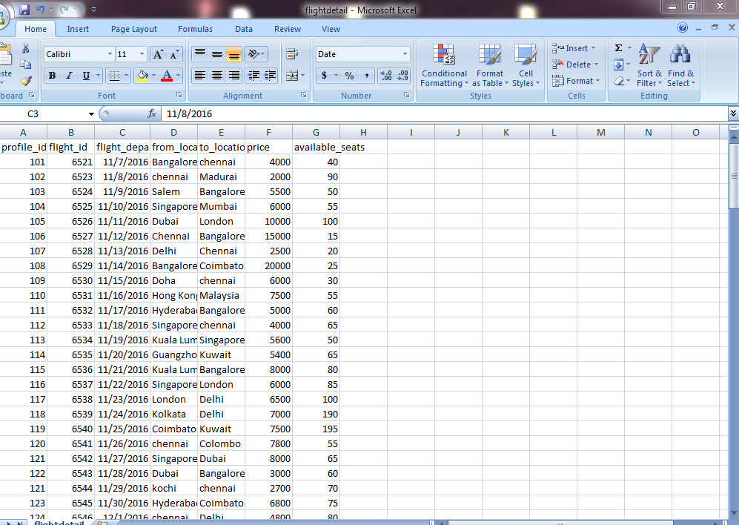

Payment Details



Pessanger Detail


TicketInfo



Dataset providing in the MySQL database
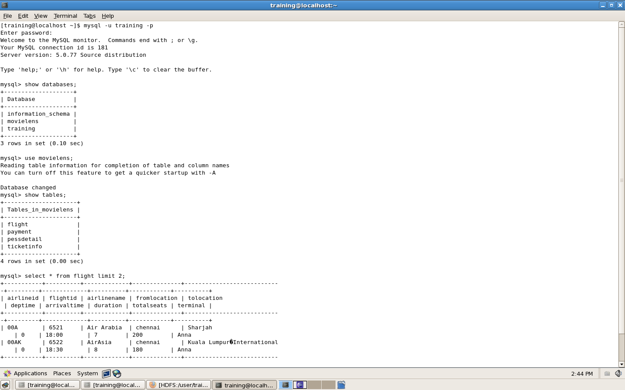

HDFS ://localhost:50070
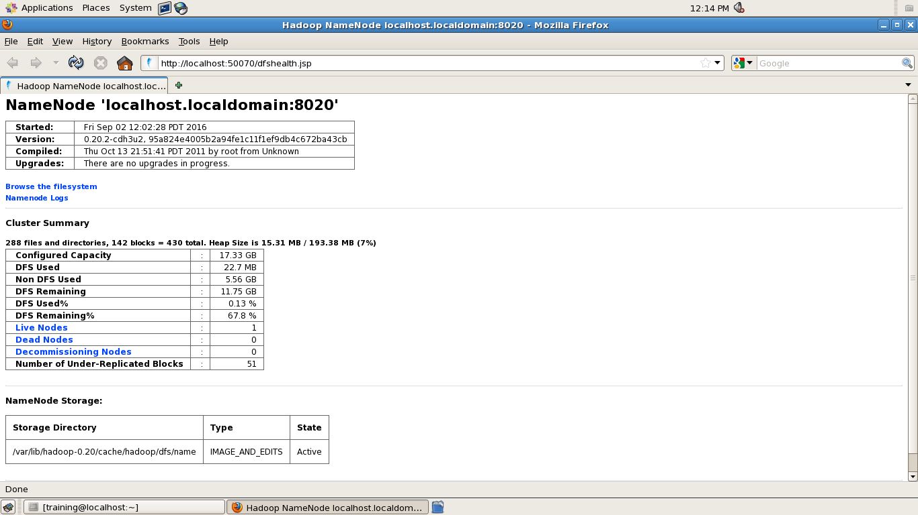

Working with sqoop:
How To Import Table(flight)Mysql Database To Hadoop[HDFS]:Using Sqoop Tool
[training@localhost ~]$ sqoop import --connect jdbc:mysql://localhost/movielens --username training –password --table flight --m 1 --target-dir fligh

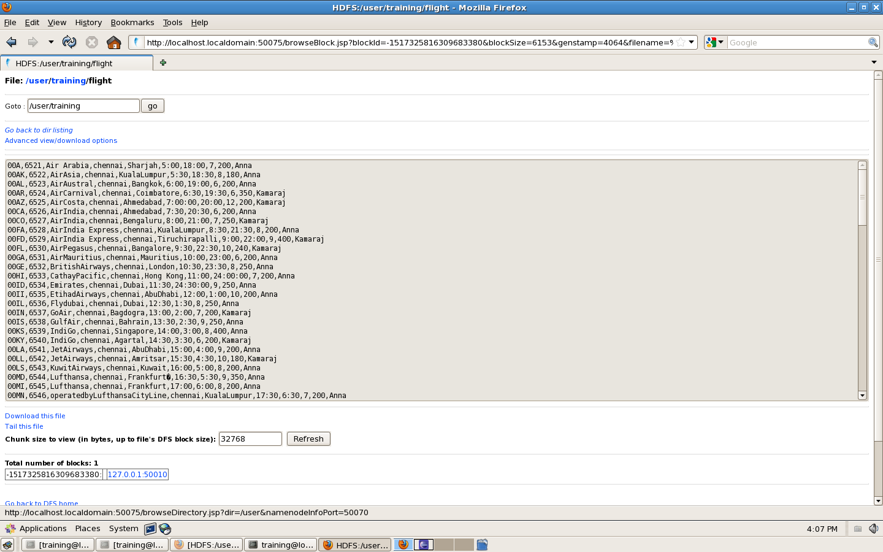

To Retrieve the Particular columns
training@localhost ~]$ sqoop import --connect jdbc:mysql://localhost/movielens --username training --password training --table flight --fields-terminated-by '\t' --m 1 --columns "flightid,airline_name,from_location,to_location"

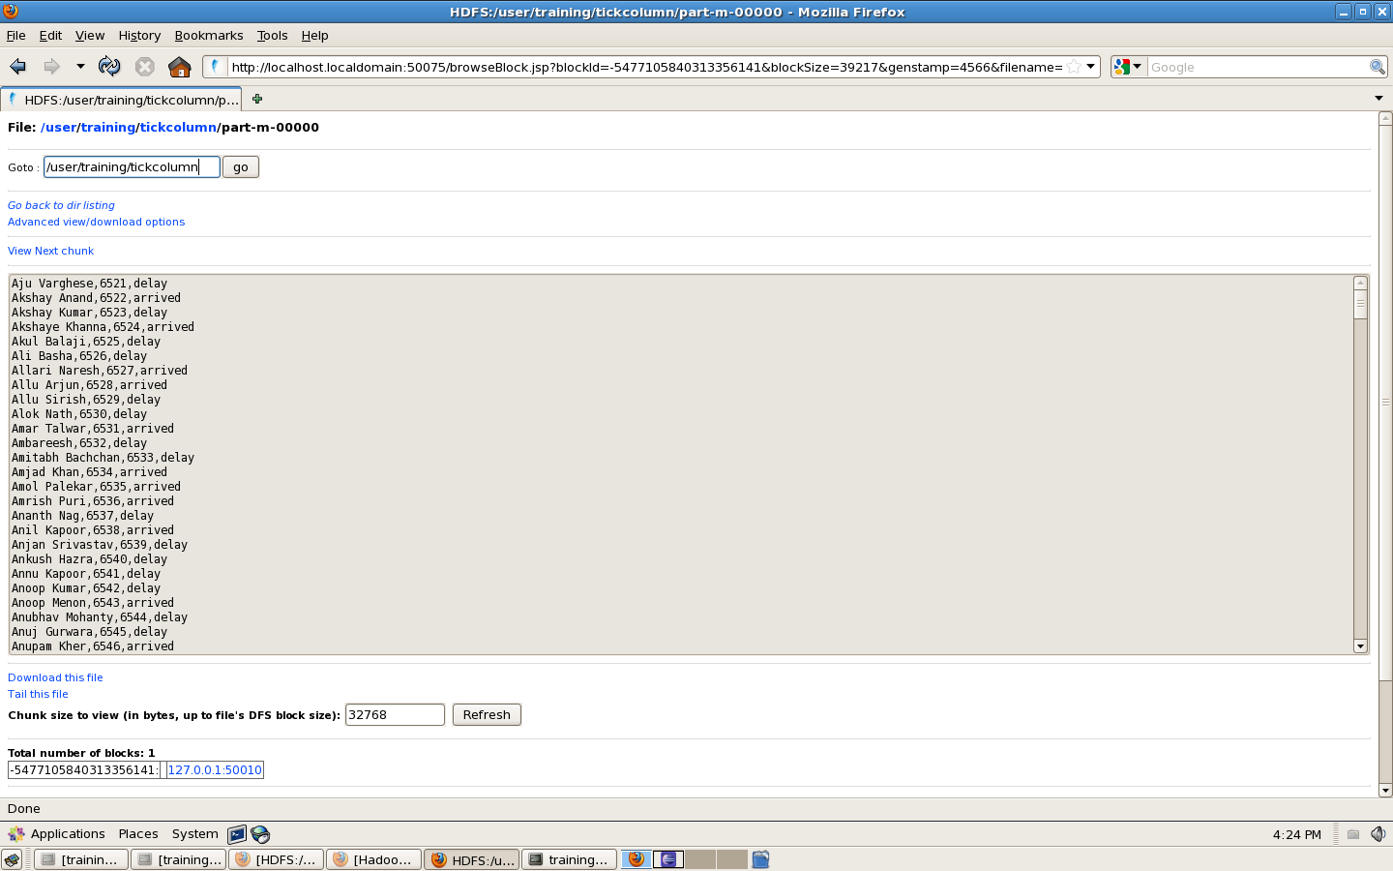

To Retrieve the Particular columns with conditions appaly
sqoop import --connect jdbc:mysql://localhost/movielens --username training --password training --table ticketinfo --m 1 --columns "ticketid,username,flightid,flight_dept_date" --where "delay='20min'" --target-dir tic11
"

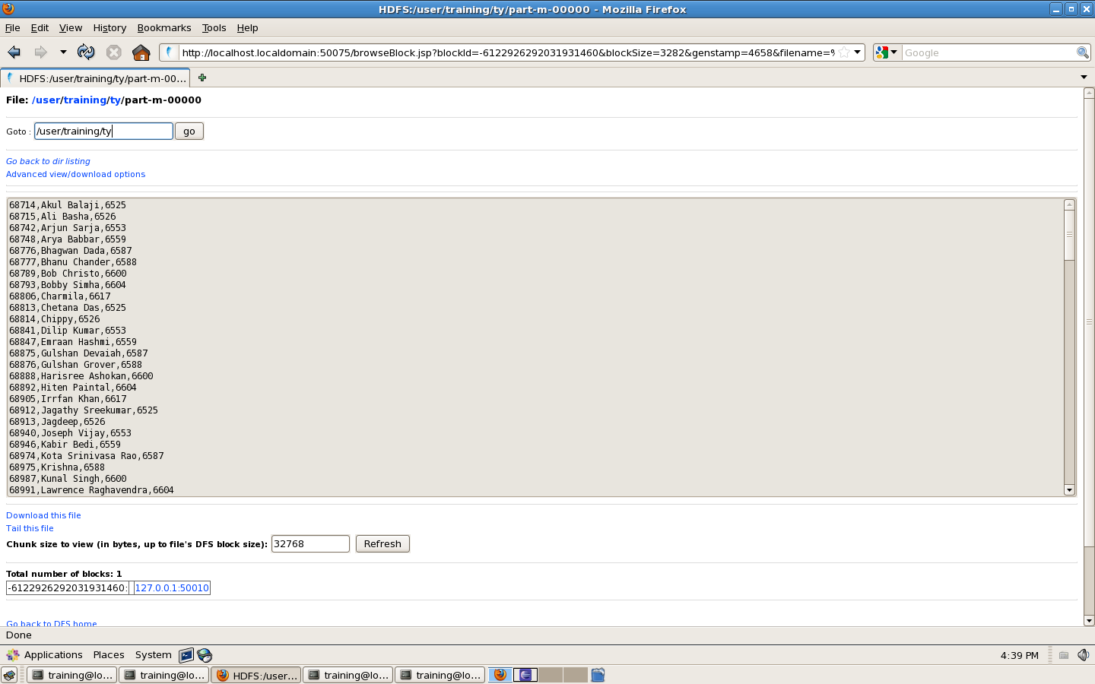

Working with Hive:

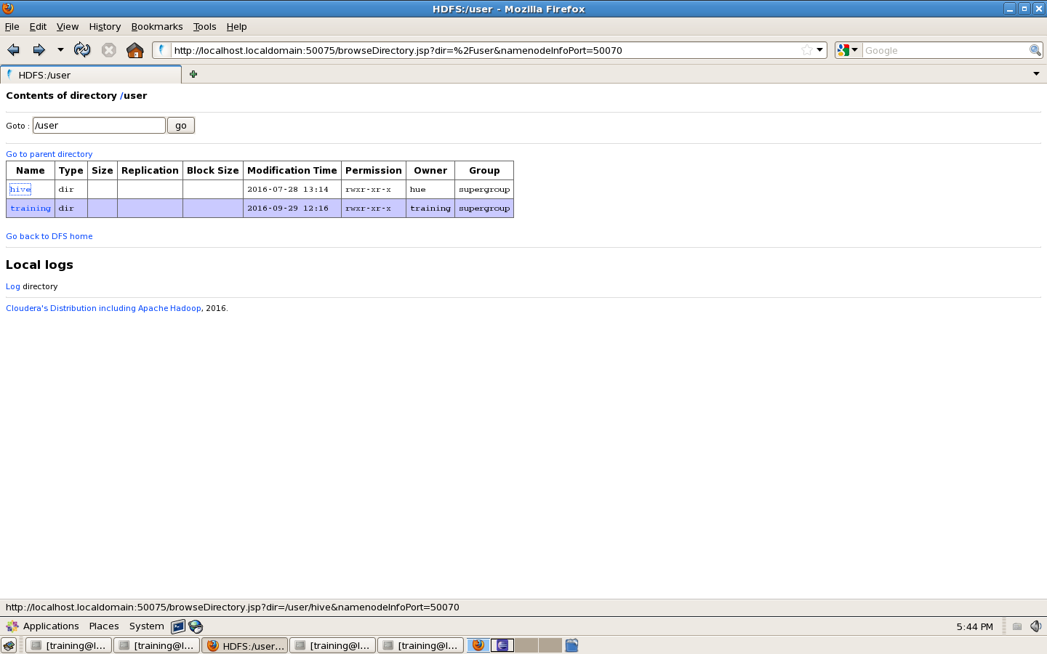

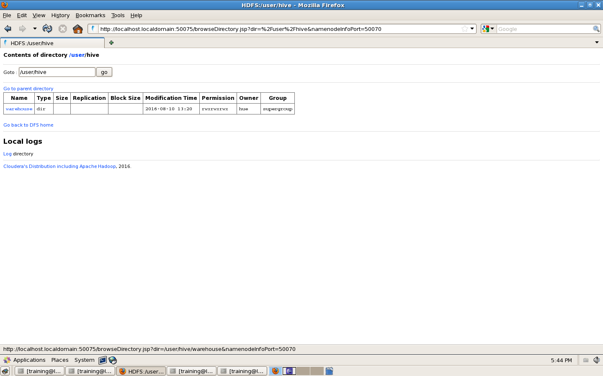

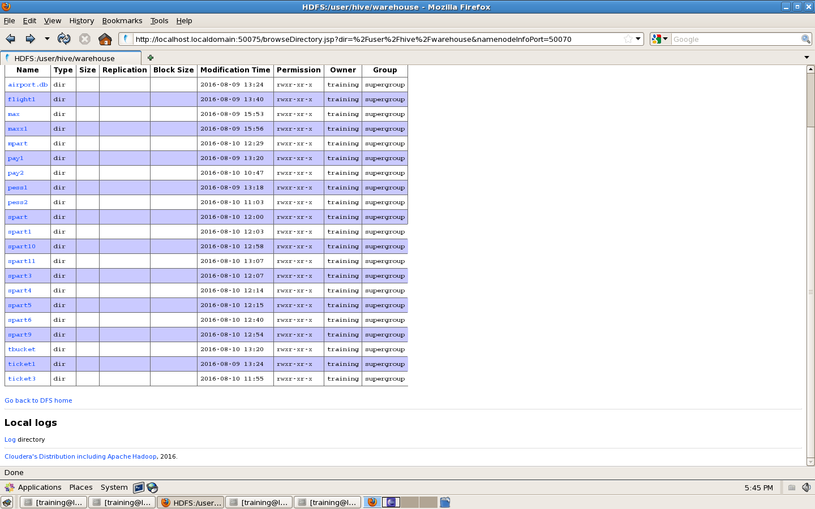

Partitions in hive:
Partitioned Table
hive> create table spart(tid bigint,userid bigint,uname string,flightid bigint,fromlocation string,tolocation string,depdate string,delay bigint,status string)
> partitioned by (s string)
> row format delimited
> fields terminated by ',';
hive> insert overwrite table spart partition (s='arrived') select * from ticket1 where status='arrived';

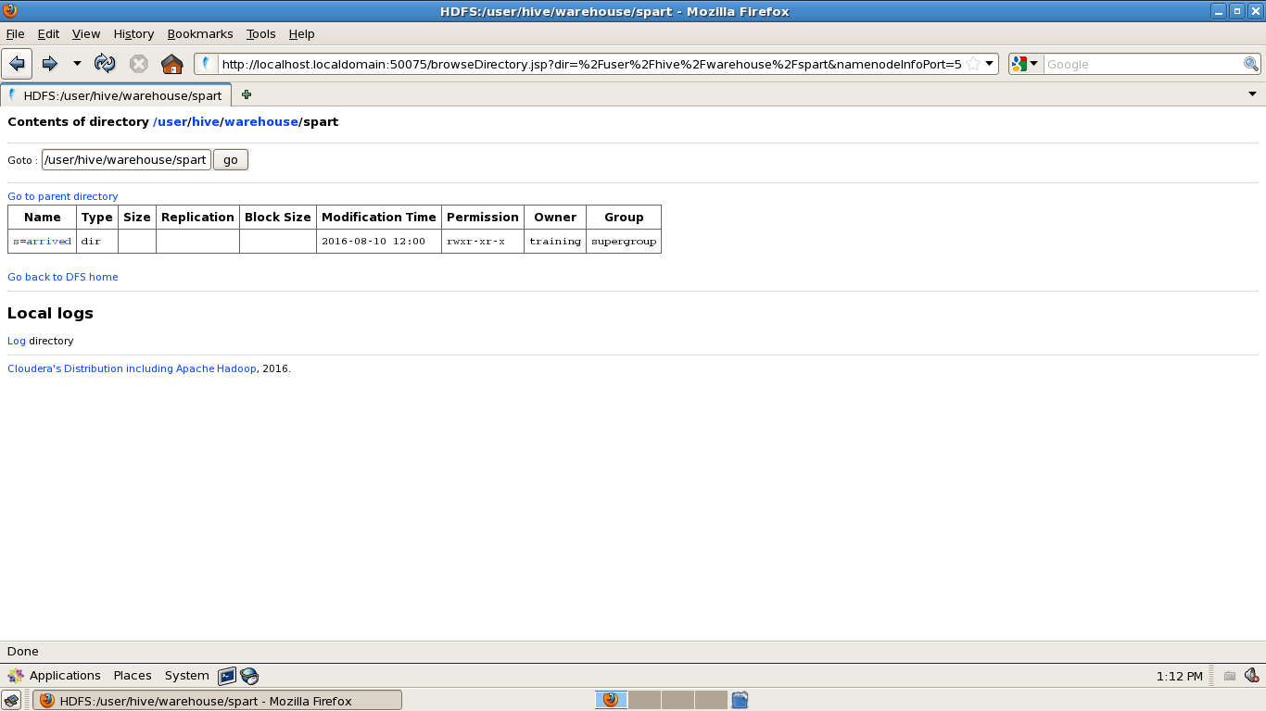

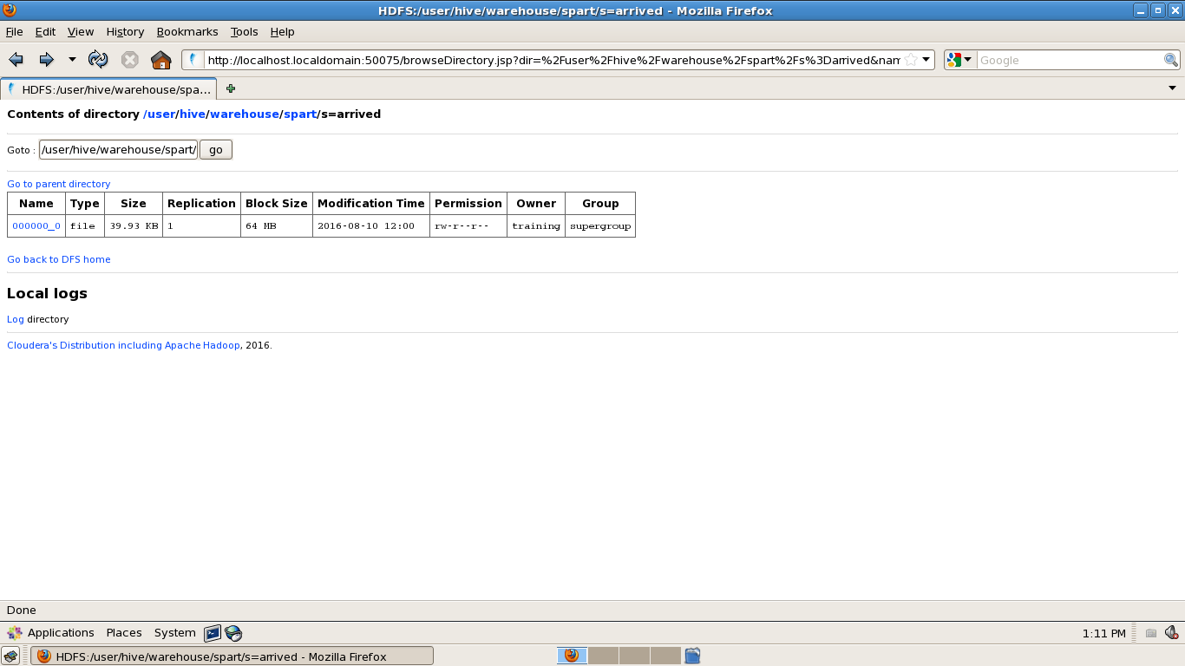

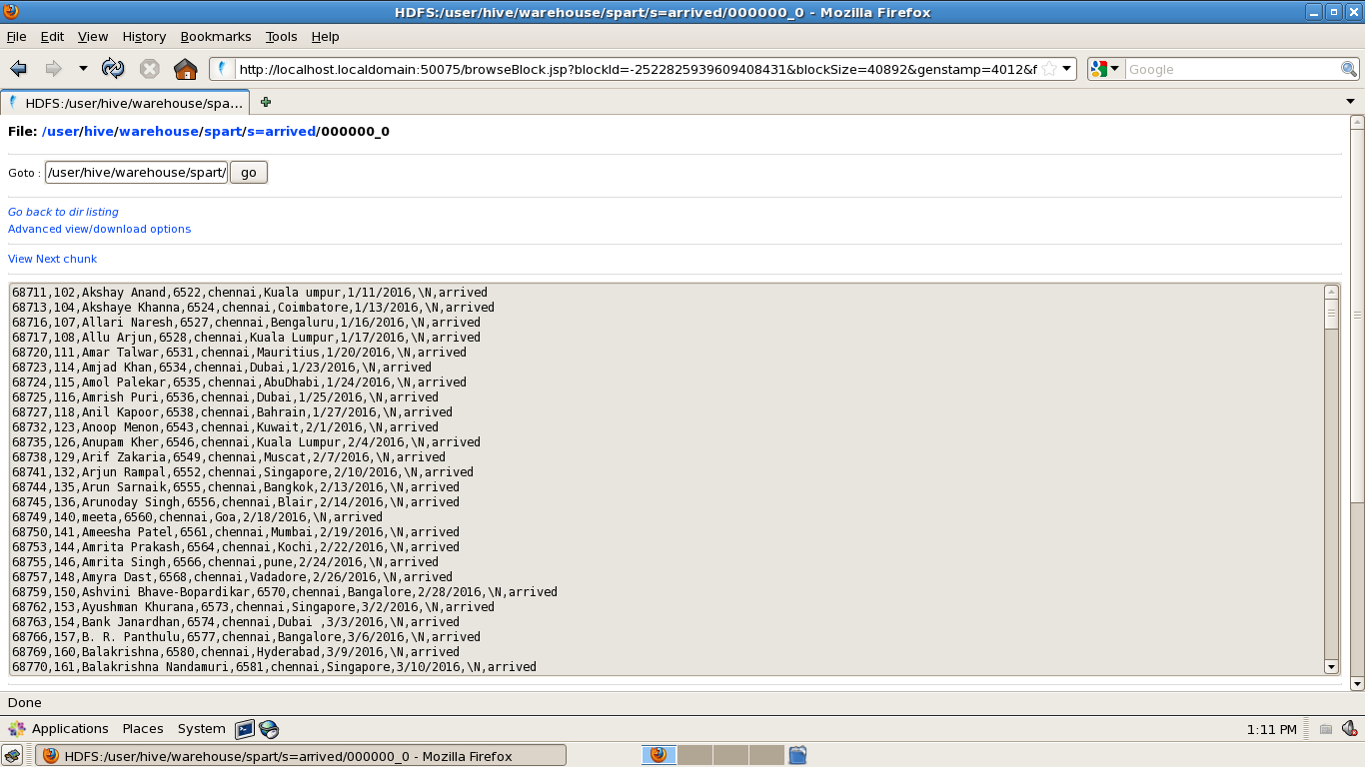

Working with pig:

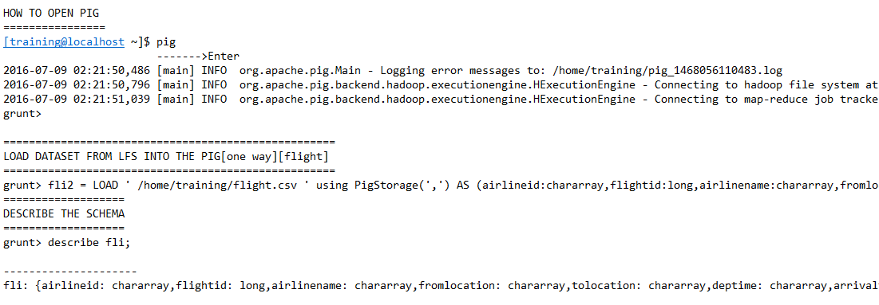
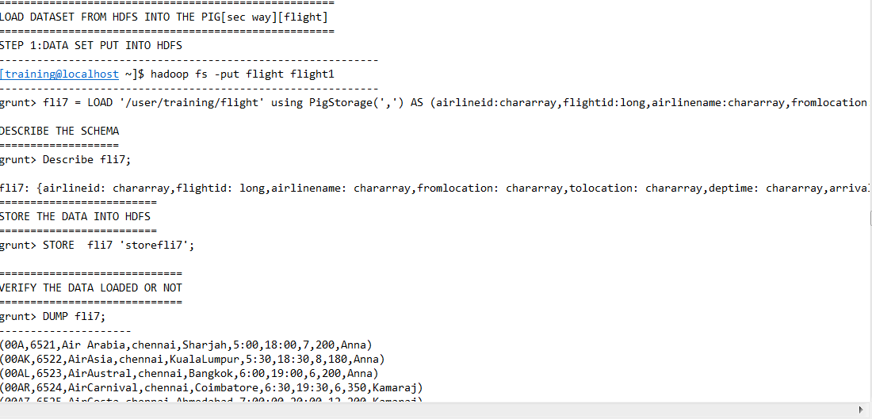

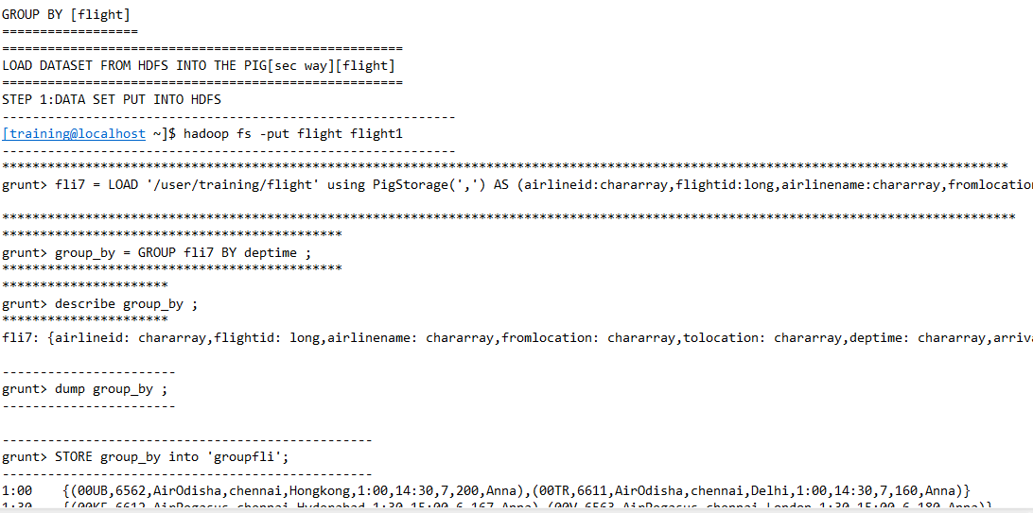

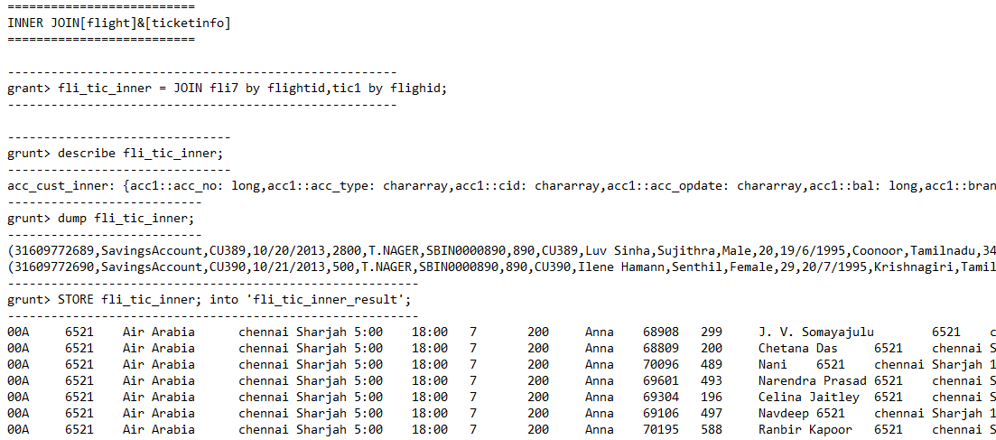

Working with java mrjob:
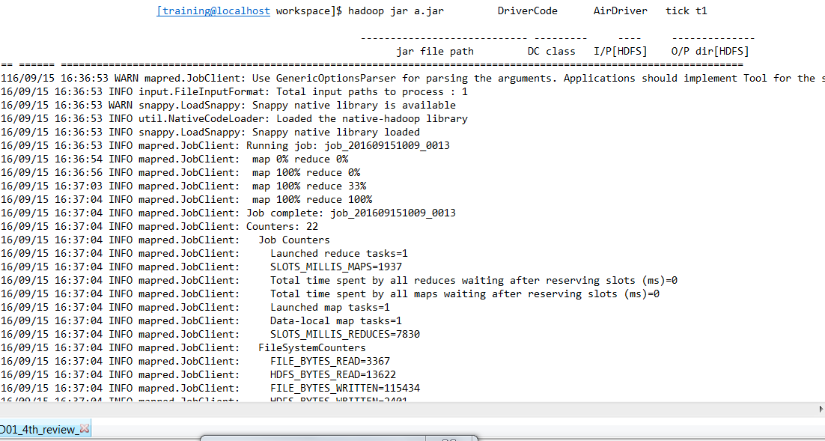

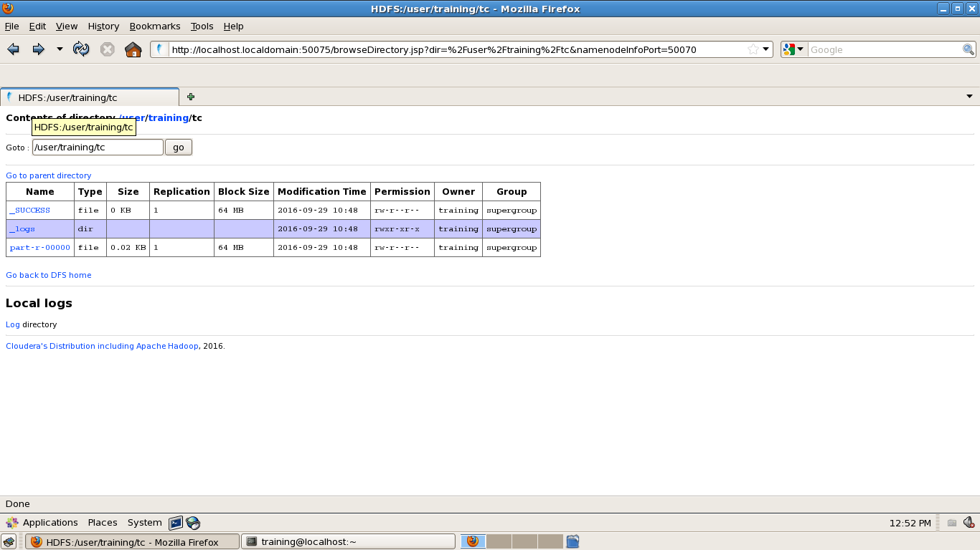

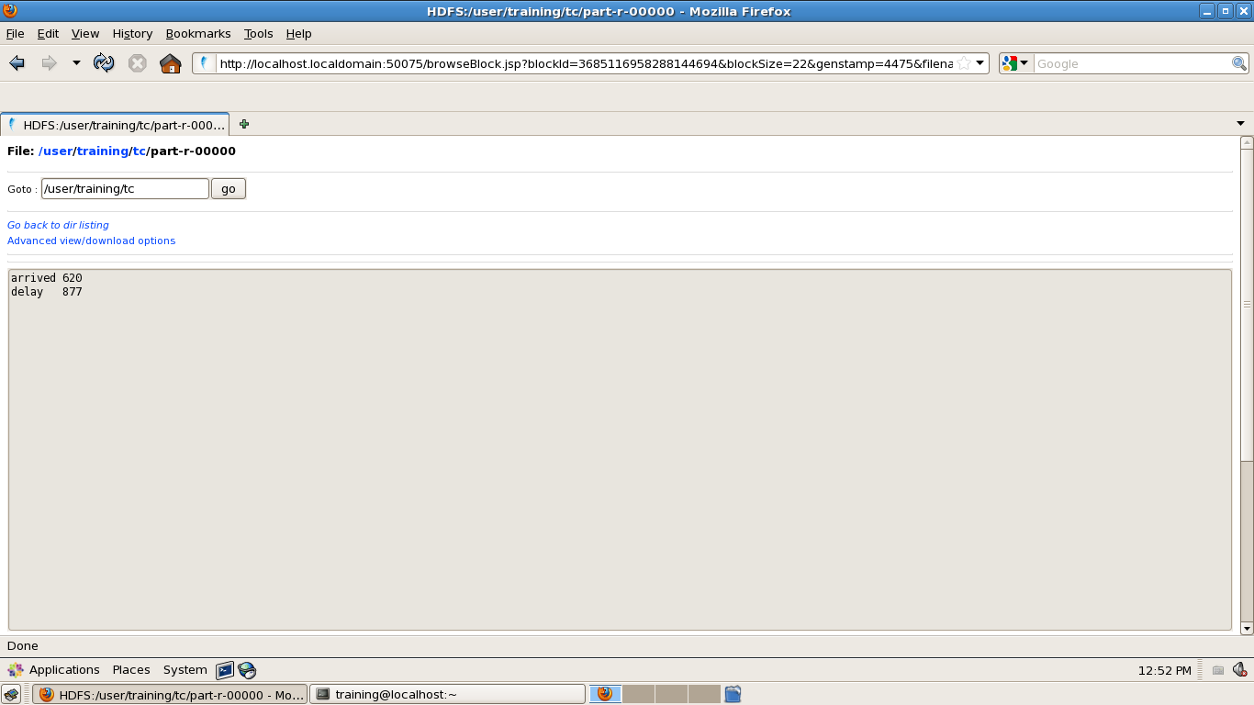

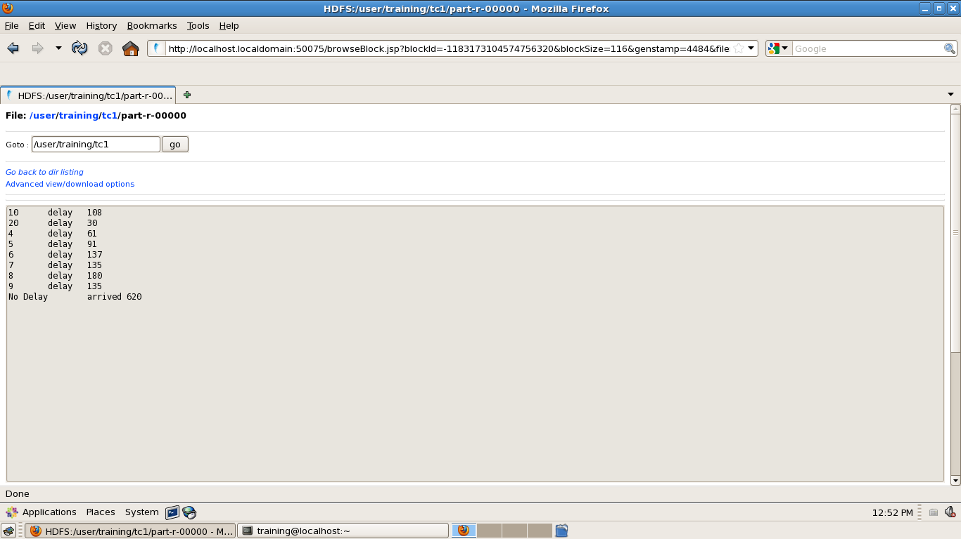

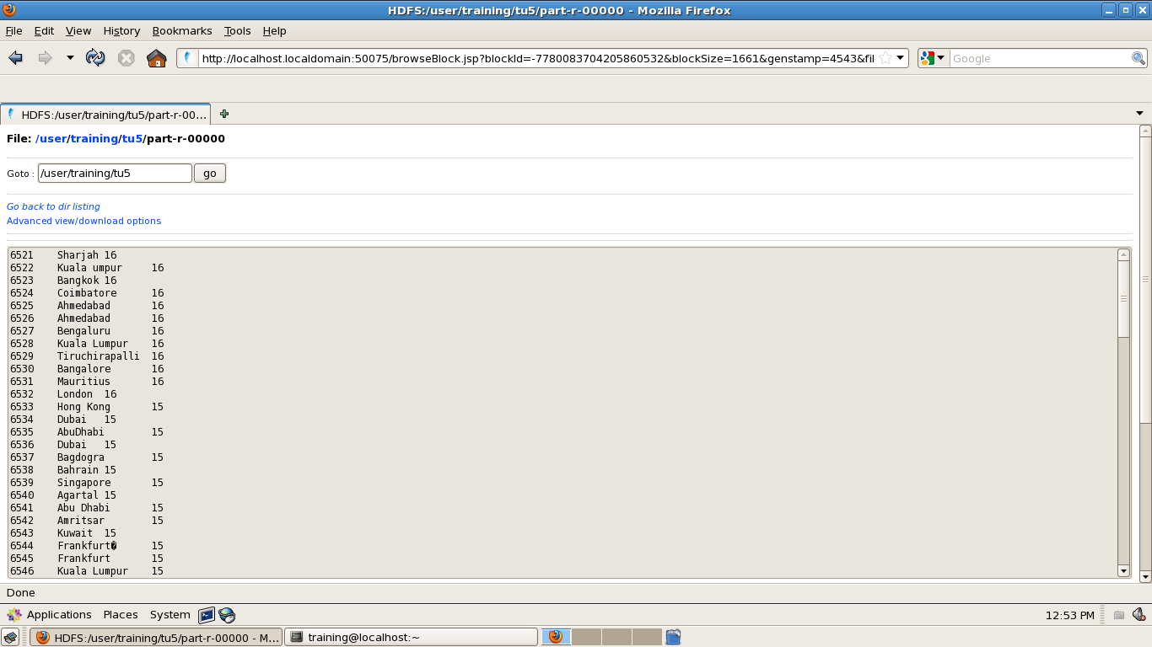

CHAPTER 8
APPLICATION
8.1 GENERAL
Sometimes the reasons behind something success can be staring you right in the face. For Hadoop, the biggest motivator in the market is simple: Before Hadoop, data storage was expensive. Hadoop, however, lets you store as much data as you want in whatever form you need, simply by adding more servers to a Hadoop cluster. Each new server (which can be commodity x86 machines with relatively small price tags) adds more storage and more processing power to the overall cluster. This makes data storage with Hadoop far less costly than prior methods of data storage.

8.2 APPLICATION

Facebook using Hadoop:
At Facebook, Hadoop has traditionally been used in conjunction with Hive for storage and analysis of large data sets. Most of this analysis occurs in offline batch jobs and the emphasis has been on maximizing throughput and efficiency. These workloads typically read and write large amounts of data from disk sequentially. As such, there has been less emphasis on making Hadoop performant for random access workloads by providing low latency access to HDFS. Instead, we have used a combination of large clusters of MySQL databases and caching tiers built using memcached. In many cases, results from Hadoop are uploaded into MySQL or memcached for consumption by the web tier.
Twitter using Hadoop:
Twitter has large data storage and processing requirements, and thus we have worked to implement a set of optimized data storage and workflow solutions within Hadoop. In particular, we store all of our data LZO compressed, because the LZO compression turns out to strike a very good balance between compression ratio and speed for use in Hadoop. Hadoop jobs are generally IO-bound, and typical compression algorithms like gzip or bzip2 are so computationally intensive that jobs quickly become CPU-bound. LZO in contrast was built for speed, so you get 4-5x compression ratio while leaving the CPU available to do real work. For more discussion of LZO, complete with performance comparisons we did a while back.

8.3 FUTURE ENHANCEMENTS
We are using spark we can get result hundred times faster than Hadoop. The secret is that it runs in-memory on the cluster, and that it isn't tied to Hardtop’s MapReduce two-stage paradigm. This makes repeated access to the same data much faster. Spark can run as a standalone or on top of Hadoop YARN, where it can read data directly from HDFS.

8.4 CONCLUSION:

In this paper we have presented a new approach called Learning Analytics and Predictive analytics to identify academically at-risk in Airport and to predict Airport information . This research develops a new methodology using Hadoop,, to determine satisficing takeoff and landing sequences and their delay time. The roles and interests of the each users are formulated. The flights functions are derived for each user to determinethe satisficing decisions.
.

8.5 REFERENCES:
[1] A. R. Odoni, “The flow management problem in air traffic control,” in Flow Control Congested Networks. New York, NY, USA:Springer-Verlag, 1987, pp. 269–288.
[2] R. L. Hoffman, “Integer programming models for ground-holding in airtraffic flow management,” Ph.D. dissertation, Dept. Manage. Sci., Univ.Maryland, College Park, MD, USA, 1997.
[3] M. O. Ball, R. Hoffman, C. Y. Chen, and T. Vossen, “Collaborativedecision making in air traffic management: Current and future research directions,”Univ. Maryland, College Park, MD, USA, Tech. Rep., 2000.
[4] T. D. Butler, “Optimization model with fairness objective for air trafficmanagement,” Univ. Maryland, College Park, MD, USA, Ph.D. dissertation,1998.
[5] T. Vossen and M. Ball, “Optimization and mediated bartering models forground delay programs,” Naval Res. Logistics, vol. 53, no. 1, pp. 75–90,
2006.
[6] “Airport Collaborative Decision Making (A-CDM),” Eur. Telecommun.Std. Inst. (ETSI), Sophia Antipolis, France, Community specification forapplication under the single European sky interoperability regulation,
Tech. Rep. EC552/2004, 2010.
[7] A. C. de Arruda, L. Weigang, and V. Milea, “A new airport collaborativedecision making algorithm based on deferred acceptance in a two-sided market,” Expert Syst. Appl, vol. 42, no. 7, pp. 3539–3550, 2015.
[8] DECEA, “Brazil’s measures for ATFM optimization during the FIFA Brazil 2014 World Cup,” in Proc. 14th Workshop/Meet. SAM Implement.Group., Lima, Peru, Nov. 2014, pp.
[9] M. Ball, G. Donohue, and K. Hoffman, “Auctions for the safe, efficientand equitable allocation of airspace system resources,” in Combinatorial Auctions, P. Cramton, Y. Shoham, and R. Steinberg, Eds. Cambridge,
U.K.: MIT Press, 2005, pp. 507–538.
[10] D. Gale and L. S. Shapley, “College admissions and the stability of marriage,” Amer. Math. Monthly, vol. 69, no. 1, pp. 9–15, 1962.
[11] S. R. Wolfe et al., A Multi-Agent Simulation of Collaborative Air Traffic Flow Management. Multi-Agent Systems for Traffic and Transportation Engineering, A. L. C. Bazzan and F. Klugl, Eds. Hershey, PA, USA:
Inf. Sci. Ref., 2009.
[12] J. Schummer and R. V. Vohra, “Assignment of arrival slots,” Amer. Econ.J., Microecon., vol. 5, no. 2, pp. 164–185, 2013.
[13] L. L. Cruciol, A. C. de Arruda Jr., L. Weigang, L. Li, and A. M. Crespo,“Reward functions for learning to control in air traffic flow management,”
Transp. Res. C, Emerging Technol., vol. 35, no. 10, pp. 141–155, 2013.
[14] C. Almeida, L. Weigang, and G. V. Meinerz, “Satisficing collaborative
decision making and controlling for airport management,” in Proc.IEEE/ASME 10th Int. Conf. MESA, Sep. 2014, pp. 1–6.
[15] L. Weigang, M. V. P. Dib, D. P. Alves, and A. M. F. Crespo, “Intelligentcomputing methods in air traffic flow management,” Transp. Res. C,Emerging Technol., vol. 18, no. 5, pp. 781–793, 2010.
[16] K. Tumer and A. K. Agogino, “Improving air traffic management with alearning multiagent system,” IEEE Intell. Syst., vol. 24, no. 1, pp. 18–21,Jan./Feb. 2009.
[17] L. L. Cruciol, L. Weigang, L. Li, and J. P. Clarke, “Air traffic flowmanagement data mining and analysis for in-flight cost optimization,”in Engineering and Applied Sciences Optimization, vol. 1. New York,NY, USA: Springer-Verlag, 2015, pp. 73–86, dedicated to the memory ofProfessor M.G. Karlaftis.
[18] “Manual on System Wide Information Management (SWIM) Concept,”
Int. Civil Aviation Org. (ICAO), Montreal, QC, Canada, no. 10039

